© ABB Limited 2013
This document contains information that is confidential. It must only be used for the agreed purpose for which it is provided. The contents of this document must not be reproduced or distributed in whole or in part without the written consent of ABB Limited or its authorised representatives.

Title | Access Right Management in the Common Framework:  Subsystem Software Design Description
Distribution | Software Archive
Author | Peter Vince, Paul Li | Date | See Revision
Review | See Review chapter | Date
Approved | Rock-RenDong Li | Date | 2013-10-11
Remarks

Contents

1 Context 4
1.1 Overview 4
1.2 Use Case Diagram 5
1.3 Definitions 6
1.4 Acronyms and Abbreviations 6
2 Data Sheet 7
3 Detailed Description 10
3.1 Static Modelling 10
3.2 Dynamic Modelling 12
3.3 Class Design 17
3.4 Detailed Design 17
3.5 Design Decisions and Limitations 23
3.5.1 Check Access Rights Method 23
3.5.2 Access Rights Table 23
3.5.3 User Access Level 24
3.6 Hardware Dependencies 25
3.7 Memory Usage 25
3.8 Data Object Description 26
4 Appendix – Password Hashing Method 27
4.1 Basic Arrangement 27
4.2 Algorithmic Implementation 28
5 Addendum – Access Rigth Management Table 30
5.1 Definitions 30
5.2 Acronyms and Abbreviations 30
5.3 Design Decisions and Limitations 30
5.3.1 Check Access Rights Method 30
5.3.2 Access Rights Table(s) 31
5.3.3 User Access Level 33
6 Module Test 34
7 References 45
8 Revision History 45
9 Review 46
9.1 First review 46
9.1.1 Review-Participant 46
9.1.2 Decision of the Review 46
9.1.3 Changes Are Proved 46
9.1.4 Check List 46
9.1.5 Remarks 46

List Of Figures
Figure 1: Use Case Diagram For ARM Subsystem 5
Figure 2: Context Diagram for ARM Subsystem 10
Figure 3: ARM Subsystem Entity Diagram 11
Figure 4: Collaboration diagram for LogIn 12
Figure 5: Collaboration diagram for LogOff 13
Figure 6: Collaboration diagram for Check Access Rights 14
Figure 7: Collaboration diagram for Reset Passwords 15
Figure 8: Collaboration Diagram for Change Passwords 15
Figure 9: ARM Subsystem Class Diagram 17
Figure 10: Activity diagram for LogIn 17
Figure 11: Activity diagram for LogOff 19
Figure 12: Activity diagram for Check Access Rights 20
Figure 13: Activity diagram for Reset Passwords 21
Figure 14: Activity diagram for Change Password 22

Context
This document is a representation of analysis, planning, implementation and decision-making for the Access Right Management (ARM) Common Component subsystem. One of its major goals is to support reuse of the described subsystem.

The document is divided into two main parts:

- The first part is a data sheet intended for developers that want to reuse the subsystem, listing important issues from a black-box view.

- The second part provides a more detailed subsystem description, including design information to allow subsystem maintenance or future expansion.

Overview
This document describes the functional design specification for the ARM subsystem common component. The design described here is the result of a previous design-study of three alternative solutions [7]. The first implementation of this will be within the EMF flow meter project (see Common Software Requirements Specification [1] and project’s Overall Software Design Description [2]).

The ARM is designed as a service provider within the common framework and provides an interface for concrete implementations that will be typically product specific. The framework may provide a default implementation in later revisions.

The ARM Subsystem is intended to provide access rights management for interface subsystems (eg: HMI/HART etc “clients”) to call upon when determining whether a particular user may or may not read or write a particular device configuration.

Use Case Diagram
The following Use Case diagram illustrates the top-level use cases derived from the ARM Subsystem Requirements Specification [3].

Figure 1: Use Case Diagram For ARM Subsystem
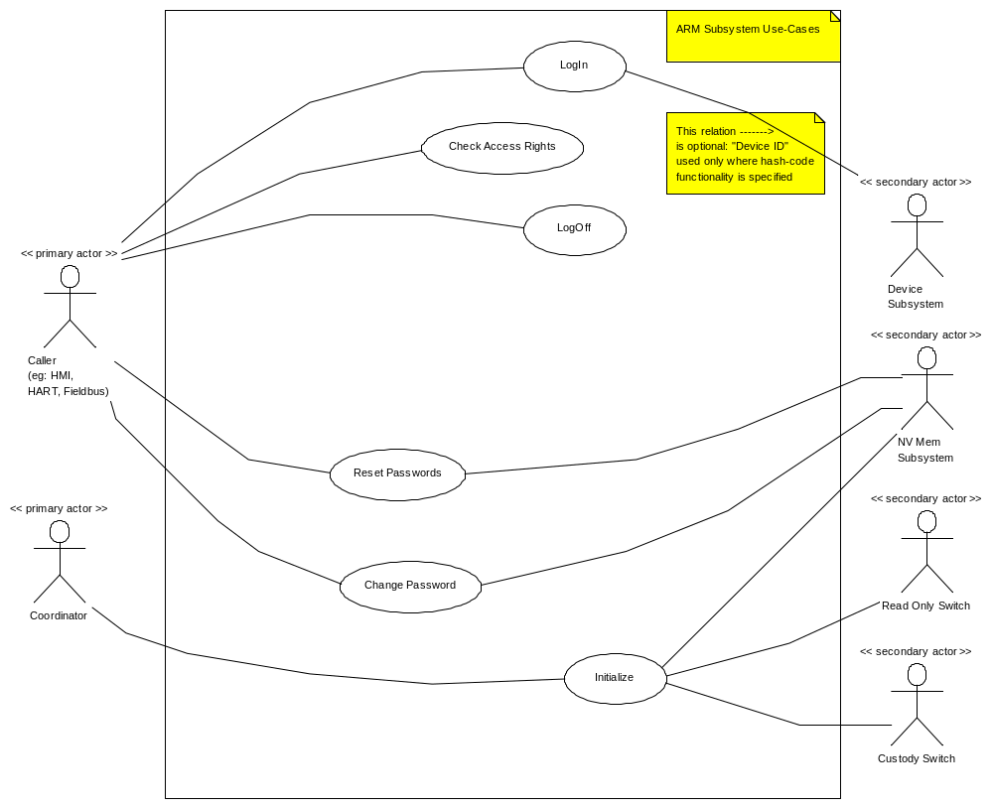

For use-case text descriptions, see [4]

Definitions

Term | Definition
Access Rights Manager | This subsystem (ARM). It has the responsibility to declare, when consulted, whether or not access (reading or writing) to an object (and/or its attribute(s)) may be granted.
ARM client | Another subsystem that wants to change the device configuration and uses the ARM to check if access is granted or not. Typical clients are HMI, HART, Fieldbus and specific interfaces for factory configuration.
Access Rights Table | Table of access rights for each configurable or readable item. A full description appears in section 3.5.2. Access Rights Table.
Custody Switch | A hardware jumper that permits configuration changes to selected parameters only.
Device Id | An identity number unique to the device in which the ARM is being used.
Device Subsystem | Subsystem responsible for handling Device Id.
Fieldbus | The Fieldbus® protocol. This incorporates Fieldbus protocols like Fieldbus Foundation, Profibus PA, Profibus DP
HART Subsystem | Subsystem responsible for interfacing to HART protocol communications.
HMI Subsystem | Subsystem providing HMI for local user access via display and key input.
PIN (“rolling” PIN) | Sequence number which increments/rolls-over upon each successful access, and also upon 3 failed access attempts
Read Only Switch | A hardware switch that makes all objects that normally are available at the current access level, read-only.

Acronyms and Abbreviations

ARM | Access Rights Manager (or Management)
HART | Highway Addressable Remote Transducer
HMI | Human Machine Interface
HW | Hardware
I/O | Input/Output
N/A | Not Applicable
NV | Non-volatile
PIN | Per-access Incremental Number
RAM | Random Access Memory
SW | Software
TBD | To Be Determined

Data Sheet
This chapter gives an overview of important details of the subsystem. It is intended for other developers who may wish to reuse this subsystem.

Category | Item | Description
Development | Version / Status | Released
Development | Known Bugs | Not known
Development | Planned Improvements | None
HW-Platform | Type | M16C
HW-Platform | Clock | 3.6MHz
SW-Development Environment | Compiler | M16C6x / M16C20 / R8C IAR C/EC++ Compiler Version 3.40x
SW-Development Environment | Operating System | Segger embOS for M16C6x / M16C20 / R8C version 3.28g
SW-Development Environment | Case / Code-Generation Tool | None
Required Resources | Operating System | None
Required Resources | HW | Pins for custody and read-only switches are required where these options are specified.
Required Resources | RAM | Refer to section on Memory Usage. The breakdown is:  Private subsystem data: 20 Bytes  Total = 20 Bytes  NB: Assumes HMI, and HART Clients only initially; increases by 2 bytes per new Client added.  Stack allocation for EXE and SRV methods:  TBD Bytes
Required Resources | NVRAM | Refer to section on Memory Usage:  Configuration data  Total = 38 Bytes  NB: Assumes HMI, and HART Clients only initially; increases by 2 bytes per new Client added.
Required Resources | ROM | None.
Required Resources | Execution Time (ms) | Method Name | Min time | Max time |  | Average Time
Required Resources | Execution Time (ms) | LogInExe | 3.11234 | 3.38769 |  | 3.20856
Required Resources | Execution Time (ms) | LogOffEXE | 2.00167 | 2.09578 |  | 2.03009
Required Resources | Execution Time (ms) | CheckAccessRightsSRV | 25.00134 | 30.675449 |  | 26.1167
Required Resources | Execution Time (ms) | ResetPasswordsEXE | 2.00994 | 2.02626 |  | 2.01721
Required Resources | Execution Time (ms) | ChangePasswordEXE | 2.01089 | 2.02782 |  | 2.01354
Required Resources | Execution Time (ms) | GetAttribute | 9.75334 | 10.231008 |  | 9.80012
Required Resources | Execution Time (ms) | PutAttribute | 9.74551 | 10.37798 |  | 9.81993
Required Resources | Special HW | None
Required Resources | Subsystems | 1.Device,  2.NVRAM,
Required Resources | Data Objects
Standards | Safety | This design is not especially for usage in a SIL2 device. However it already follows the key process (Process5k / PSM) necessary for getting SIL2 approval. For a later usage in a SIL2 device concrete steps have to be defined and executed.
Standards | Other | None
Documentation | Requirements / Use Cases | Requirement Specs:  http://myportal.de.abb.com/sites/process5k/proj/emf/software/Scope/Common Software Requirement Specification.doc  http://myportal.de.abb.com/sites/process5k/proj/emf/software/Subsystems/ARM/ARM Subsystem Requirements.doc  Use Case templates:  http://myportal.de.abb.com/sites/process5k/proj/emf/software/Subsystems/ARM/ARM Subsystem Use Cases.doc
Documentation | Public Interface Description | Initialize() method; must be called prior to any other operations that use this subsystem.  LogInEXE() called by a client in respect of an authorised user in order to gain standard, advanced, or service level access.  LogOffEXE()called by a client in order for a logged-in user to relinquish access.  CheckAccessRightsSRV() called by a client for a logged-in user in order to determine (via the information in the Access Right Table) whether read/write/no access can be granted in respect of a particular subsystem parameter.  ResetPasswordsEXE() called by a clients’ service-level user in order to reset subordinate level passwords to default.  ChangePasswordEXE() called by a user of a client; a user may change the password relating to his/her own, or any subordinate, access level.  See section 3.8 for descriptions of the Data Objects  All other standard T_Unit methods.
Documentation | Test Specification | Test Plan [6] TBD
Functionality | Configuration Options | Configuration |  |  | Protection Type
Functionality | Configuration Options |  |  |  | Simple |  | Complex
Functionality | Configuration Options | User Groups (Basic, Standard, Advanced, Service) |  |  | 1 or 2 |  | 3 or 4
Functionality | Configuration Options | Assign User Group Rights to Data Objects (R/W, RO, WO, Invisible) |  |  | Yes |  | Yes
Functionality | Configuration Options | Protection Switch 1 (Custody Switch) |  |  | No |  | Yes
Functionality | Configuration Options | Protection Switch 2 (Read-Only Switch) |  |  | No |  | Yes
Functionality | Configuration Options | Simple Configurable Password(s) |  |  | Yes |  | Yes
Functionality | Configuration Options | Hash Password for Access to Service/Factory Data |  |  | No |  | Yes
Functionality | Configuration Options | Fixed Code to Reset Password(s) |  |  | Yes |  | No
Functionality | Configuration Options | Hash Code to Reset Password(s) |  |  | No |  | Yes

Detailed Description

Static Modelling

The following figure shows how different user groups interact within the device. There may be other users and interfaces. The important point to understand is that users wanting to change configuration data have to pass the ARM checking procedures before being allowed to change any subsystems’ configuration. The ARM checks the configuration change-request(s) against entries in the Access Right Table and either denies a request, or permits the user access to the appropriate subsystem configuration.

Figure 2: Context Diagram for ARM Subsystem

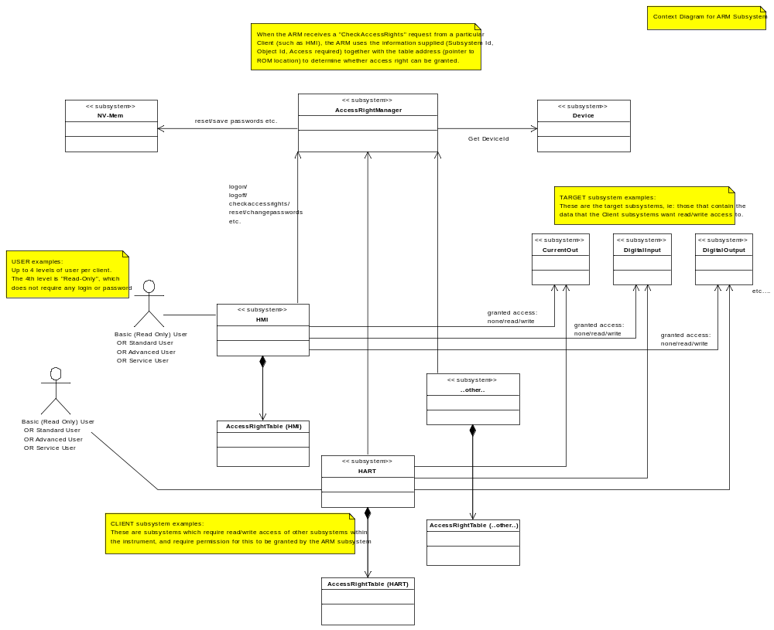

Figure 3: ARM Subsystem Entity Diagram

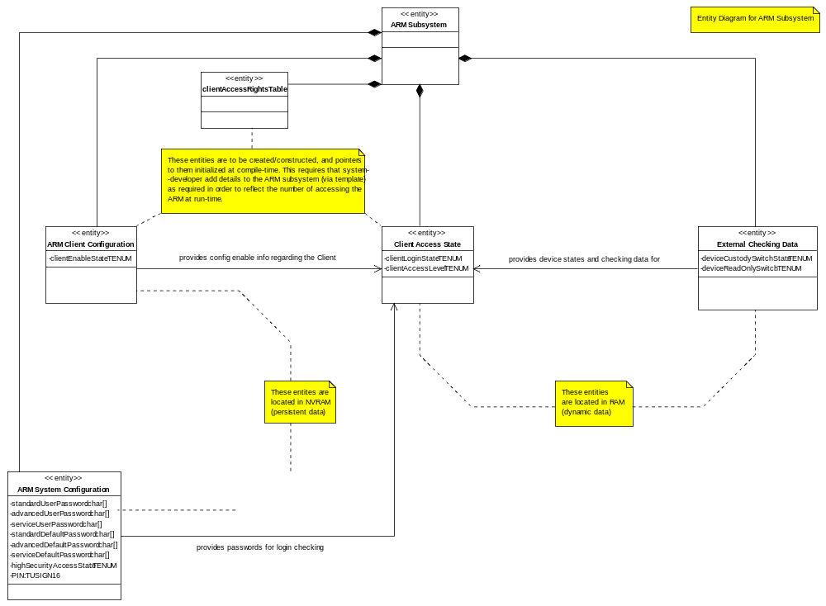

Dynamic Modelling

Figure 4: Collaboration diagram for LogIn
This collaboration diagram represents the LogIn use-case:

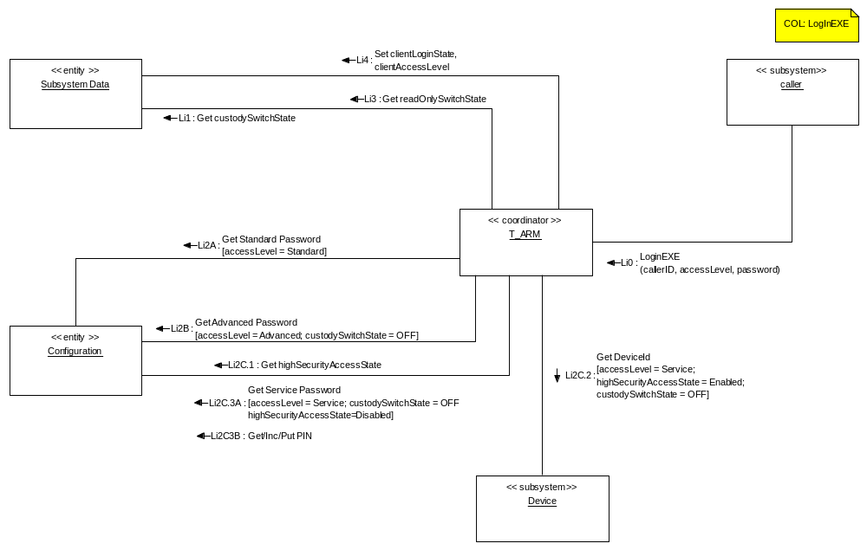

If a user wants to login to a device through for instance, the HMI, the HMI has to first access the ARM subsystem. The ARM needs to know:

  - Client who has requested LogIn(callerID) – eg : HMI
  - A user level (Standard/Advanced/Service) together with his/her password (simple or, for a Service user, hashed).
  - The status of the Custody Switch (which would have been read at initialization).

The ARM will examine the Custody Switch status in order to determine the levels of access permitted: if the switch is “off”, all following levels may apply. Otherwise, only Standard level access may be granted, and this will be with a more limited capability.

The ARM then compares the user-entered password with a stored simple password for the selected level. Optionally, for Service Level access, the ARM may be configured for higher-security in which case it needs to get the DeviceId from the Device subsystem, and also the PIN, in order to calculate a hashed password for comparison with the entered password. See appendix for details of the hasher algorithm.

If the user-entered password matches with simple/calculated hashed passwords then the ARM grants access to that user. A failed attempt to login when already logged in will result in a log-out for that Clients’ user.

To increase protection of stored simple passwords, it is proposed that the 5-digit alphanumeric string that the user enters (for login, or for password change) is hashed, resulting in a (up-to) 32-bit integer value. It is this hash result that is the format of the stored password. So for login checking, the simple password entered is “hashed”, and then compared with the stored hashed password.

This hash-code will need to be at least 26 bits in length, which is different from the hash in Service Level Access. See appendix for details of the hasher algorithm.

If one user for a particular client (ie: HMI/HART) is already logged in successfully, a user can log on to the device via that client if, for instance, he needs a high (or lower, or same) level access.

Access level information will be linked to each object within the Access Rights Table. All passwords for each user will be stored/retrieved from non-volatile memory on ARM initialize.

Figure 5: Collaboration diagram for LogOff
This collaboration diagram represents the LogOff use-case:

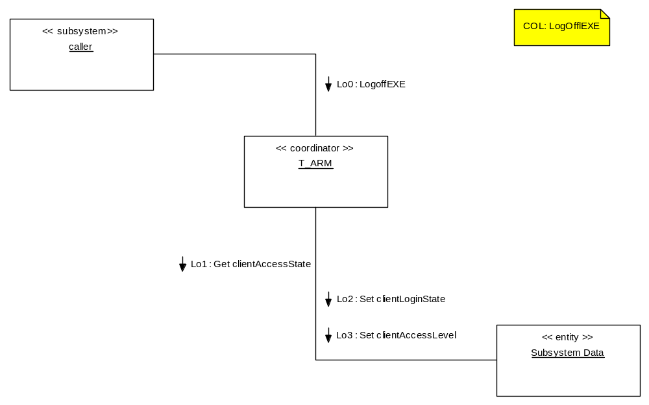

If a currently logged-in user performs a log-off operation, access to all objects reverts to Read Only Access for the Basic level (not all objects will be visible at this level). In addition, “no user” will be shown as logged in for this Client.

Figure 6: Collaboration diagram for Check Access Rights
This collaboration diagram represents the Check Access Rights use-case.

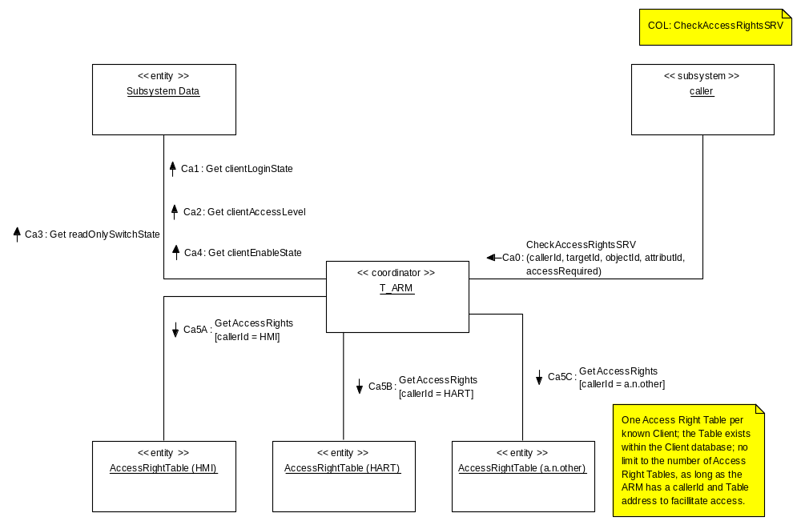

If any caller subsystem wants to know the access rights for a particular object in a target subsystem then it has to go through ARM subsystem.

The procedure will be as follow:

- If any subsystem wants to read or write any object for a particular subsystem it first needs to check for access right through ARM subsystem.
- User enters its callerId, targetId, objectId, attributeId, and the access required.
- ARM checks the Read Only switch. If it’s “On”, then user can’t be granted with write access. Read access will, however, still apply for all the objects permitted at the logged-in access level.
- ARM checks the Client Enable configuration setting. If it’s “Disabled”, then user can’t be granted with write access. Read access will, however, still apply for all the objects permitted at the logged-in access level.
- ARM accesses the Access Right Table pertaining to the Client (which is also hosted by the Client subsystem). This table has information about the access rights for a particular object that the caller wishes to read/write.
- ARM will locate the access information for the particular object and return “Access granted” or “Access not granted”, as appropriate.

NB: Table design for HMI and HART can be found in section 3.5 of this document,

The Access Right Table exists on a per-Client basis; each Client hosts its own Access Right Table. Therefore, information about all other subsystems should in place before completing the ARM subsystem design.

Figure 7: Collaboration diagram for Reset Passwords

This collaboration diagram represents the Reset Passwords use-case.

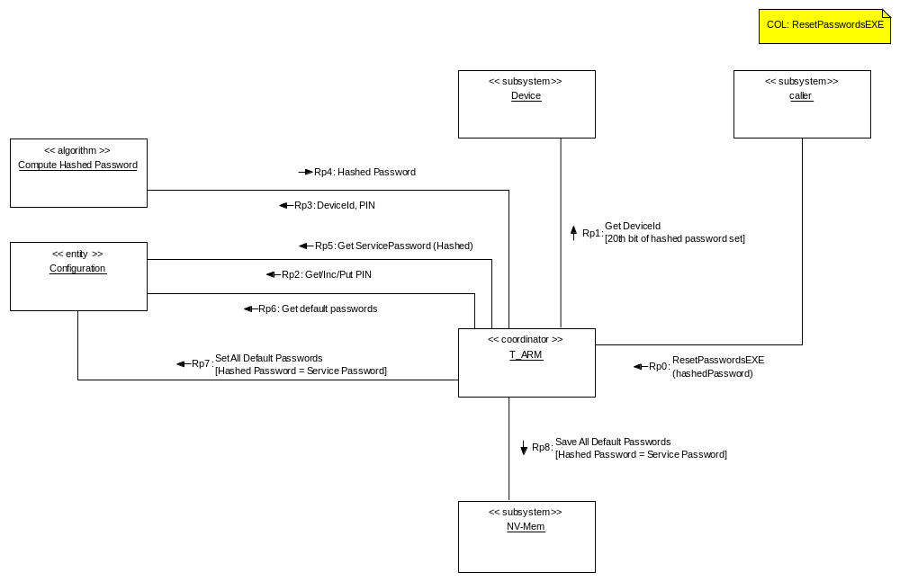

If a user wants to reset all factory passwords then he/she has to enter a hashed password with the 20th bit of the hashed password set, indicating this intention to the ARM. The ARM then has to calculate the hashed password and compare with the caller-entered hashed password. If the passwords match, the ARM then updates all passwords (including NVRAM entries) with default passwords. In this case all previously stored passwords will be overwritten in NV memory.

Figure 8: Collaboration Diagram for Change Passwords

This collaboration diagram represents the Change Passwords use-case.

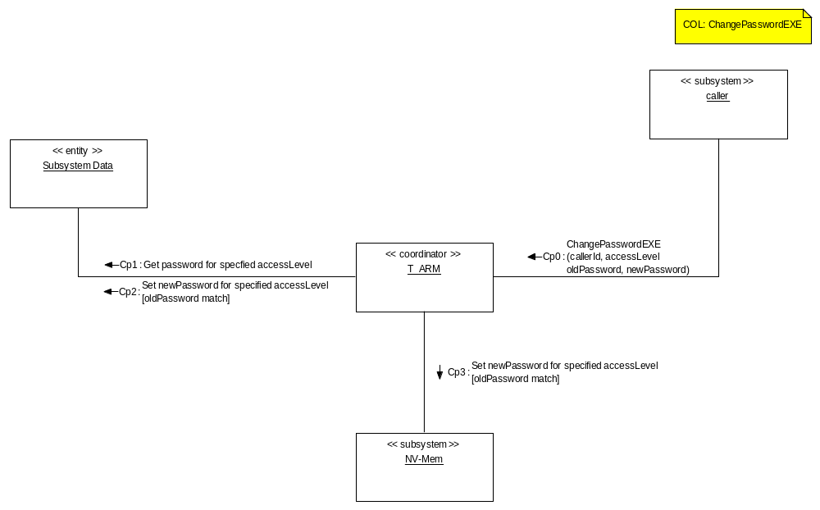

If a Service-level user wants to change the advanced password, or any user wants to change his/her own, or subordinate level, (simple) password, this has to be done via the ARM. The user has to enter the old password as well as new password. The ARM first validates the old password entry. If it matches the stored password the ARM then stores the new user-entered password, overwriting the memory-entry for the old password. The access level will be taken from that corresponding to the old password. Each occasion the user changes the password, the user-entered password will be over-written. Default passwords would normally remain unchanged. Only a Service Level user may change default passwords.

Class Design

The object-oriented design approach implies that object method calls include the address of the object’s data structure. This has not been shown in the diagrams although the C implementation requires the address to be supplied manually. The parameter for this is referred to as the “me” pointer.
eg
TUSIGN16 Get_T_UNIT (const T_UNIT SLOW *me, TUSIGN16 objectIndex,
TINT16 attributeIndex, void FAST *ptrValue);

Figure 9: ARM Subsystem Class Diagram
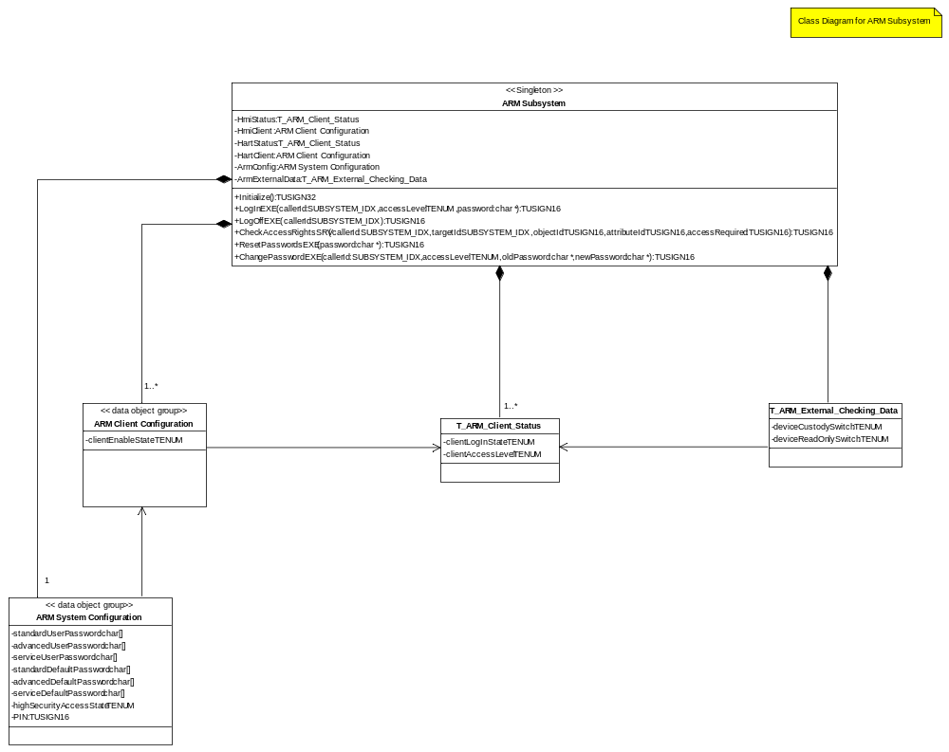

Detailed Design
Figure 10: Activity diagram for LogIn
This diagram describes the activity for LogIn:
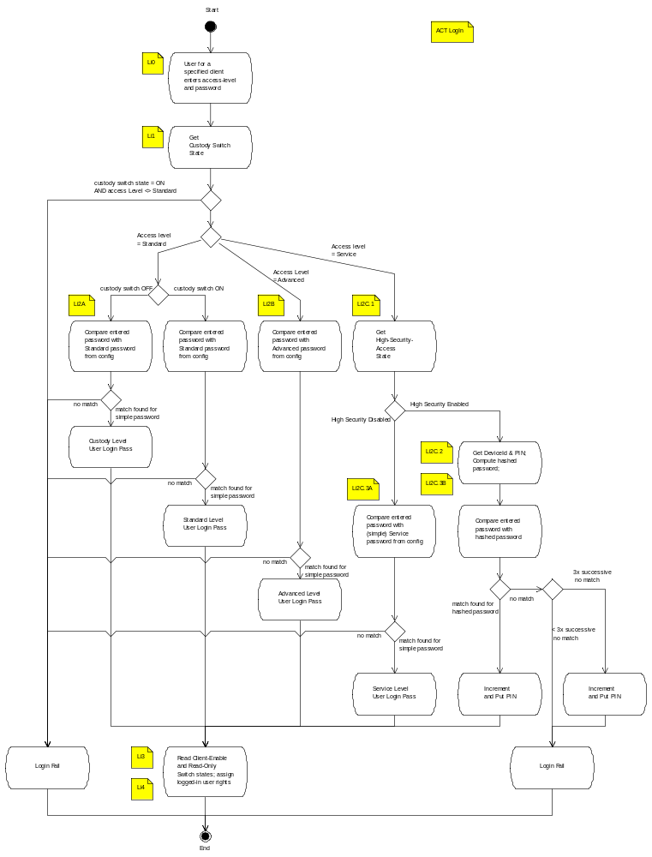
Figure 11: Activity diagram for LogOff
This diagram describes the activity for LogOff:

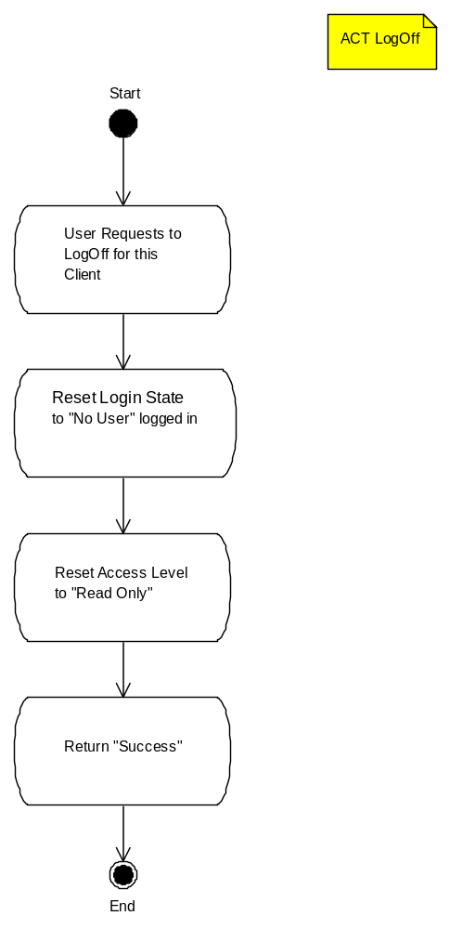

Figure 12: Activity diagram for Check Access Rights
This diagram describes the activity for Check Access Rights:

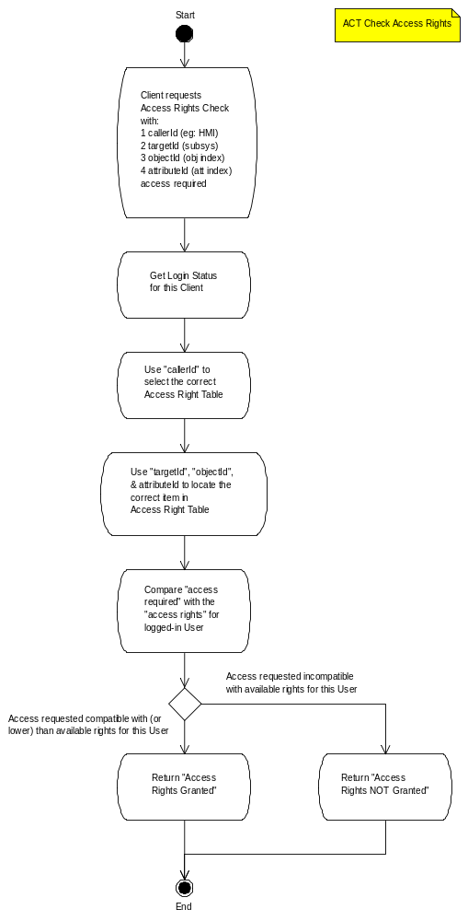

Figure 13: Activity diagram for Reset Passwords
This diagram describes the activity for Reset Passwords:

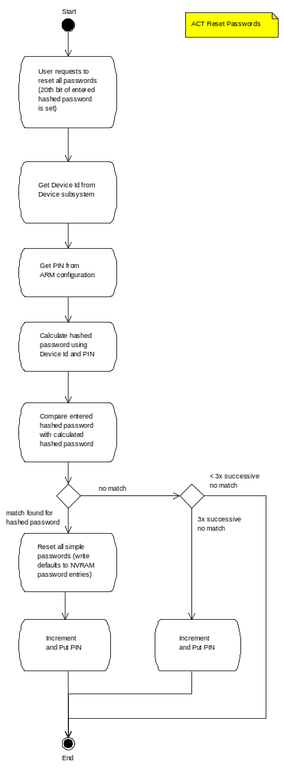
Figure 14: Activity diagram for Change Password
This diagram describes the activity for Change Password:

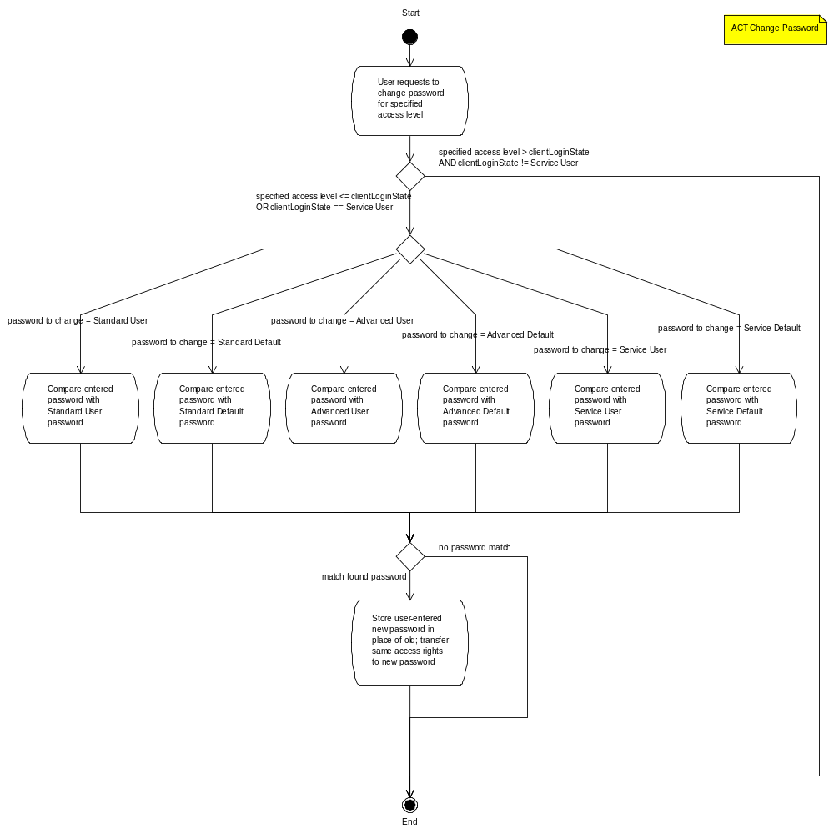

Design Decisions and Limitations

The ARM Subsystem is designed for use with the ABB BUI Common Framework running with Segger embOS operating system [5]. The proposed design has several EMF project-specific elements. This should not in any way preclude its use in other projects, and therefore as a common component. Where such descriptions are EMF-specific it should be understood that such design elements may be omitted (eg: the optional hardware switches) if another project does not require them.

Check Access Rights Method

CheckAccessRights() is a service function within the ARM which returns eTRUE if the requested access right is granted (eFALSE otherwise). It has the following arguments (parameters):

Parameter | Type | Documentation
callerId | SUBSYSTEM_IDX | An identifier that identifies the calling subsystem (e.g. HART, HMI, …)
targetId | SUBSYSTEM_IDX | An identifier that identifies the subsystem the caller wants to get access to.
objectId | TUSIGN16 | The object in the subsystem the caller wants to get access to.
attributeId | TUSIGN16 | The attribute of the object in the subsystem the caller wants to get access to.
accessRequired | TUSIGN16 | The type of access requested by the caller. This is either read-only, read-write, or no access.
Note: SUBSYSTEM_IDX is a unique identifier, which exists for each subsystem in a device (see SubsystemIdx.h).

The purpose of this check is to ascertain whether or not the proposed access described by the above entries may be granted. To do this, an Access Right Table (below, actually one table per Client) is consulted to determine a match between the request and the access-rights given in the table.

Access Rights Table

This will have the following format. Note that there is one table per client (eg: HMI/HART/etc.):

Table for > | HMI | HART
Table Entries ¬ | HMI | HART
Entry 1 | SUBSYSTEM_IDX SubsystemIdx (1) | SUBSYSTEM_IDX SubsystemIdx (1)
Entry 1 | TUSIGN16 ObjectIdx (1) | TUSIGN16 ObjectIdx (1)
Entry 1 | TUSIGN16 AttributeIdx (1) | TUSIGN16 AttributeIdx (1)
Entry 1 | TUSIGN16 AccessRights (1) | TUSIGN16 AccessRights (1)
Entry n | SUBSYSTEM_IDX SubsystemIdx (n) | SUBSYSTEM_IDX SubsystemIdx (n)
Entry n | TUSIGN16 ObjectIdx (n) | TUSIGN16 ObjectIdx (n)
Entry n | TUSIGN16 AttributeIdx (n) | TUSIGN16 AttributeIdx (n)
Entry n | TUSIGN16 AccessRights (n) | TUSIGN16 AccessRights (n)
Note: SUBSYSTEM_IDX is a unique identifier, which exists for each subsystem in a device (see SubsystemIdx.h).

Where:
SubsystemIdx is the identity of a particular target subsystem eg: DigitalOutput_IDX
ObjectIdx is the identity of a particular object in a subsystem eg: DIGITALOUTPUT_IDX_pulseWidth
AttributeIdx is the identity of a particular attribute of an object (not all objects may have this)
AccessRights is constructed as follows:

“Service” |  | “Advanced” |  | “Standard” |  | “Basic”
b7 | b6 | b5 | b4 | b3 | b2 | b1 | b0
 |  |  |  |  |  | “Custody”
b15 | b14 | b13 | b12 | b11 | b10 | b9 | b8

The two digit combinations for each of the above specified users (Basic, Standard, Advanced, Service, Custody) can each have the following combination meanings:

The “Custody” level applies when a user attempts to login with the custody-switch enabled. A user will not be able to login with any more rights than is granted here; as such the Service, Advanced, and Standard levels do not apply.

b(odd) “W” | b(even) “R” | Access
0 | 0 | No access permitted (or “invisible” to HMI)
0 | 1 | Read-only access permitted
1 | 0 | Write-only access permitted (“invisible” to HMI)
1 | 1 | Read-write access permitted

This will allow different access rights for different users from the same table.

In order to accommodate “simple” systems, it is proposed that a “wildcard” SubsystemIdx is defined with a value of “0xFFFF”, whereby if the wildcard is used as the (one and only) table-entry the access-rights shown for that entry will apply to ALL legal object/attribute Idx’s for ALL subsystems Idx’s of the device.

User Access Level

This refers to the personal access rights of a Clients’ user (when logged in), and will have the following format:

 |  |  |  |  |  | “Client Access Level”
 |  |  |  |  |  | b1 | b0

The two digit combinations shall have the following meanings:

b(1) “W” | b(0) “R” | Access
0 | 0 | No access permitted
0 | 1 | Read-only access permitted
1 | 0 | Write-only access permitted
1 | 1 | Read-write access permitted

When no user is logged in, all fields will be “01” (Read Only). When a user logs in, the access level relevant to his/her status will be filled in.

Hardware Dependencies

The ARM subsystem has a dependency on hardware only where “custody” and “read-only” switches are specified as requirements.

Memory Usage
The tables below define the memory usage for the ARM subsystem.

ARM Subsystem Data
Instances | Object Name | Type | Area | Description / Limits
Table (External) Data
1 / client | accessRightTable | Struct* | ROM | Struct as described above (3.5.2)
Client Configuration
1 / client | clientEnableState | TENUM | NVRAM | 0 = disabled (configuration disabled),  1 = enabled
ARM Subsystem Configuration
1 | standardUserPassword | TUSIGN32 | NVRAM | “Hashed” result of 5-digit alphanumeric password (Standard)
1 | advancedUserPassword | TUSIGN32 | NVRAM | “Hashed” result of 5-digit alphanumeric password (Advanced)
1 | serviceUsePassword | TUSIGN32 | NVRAM | “Hashed” result of 5-digit hashed password (Service)
1 | standardDefaultPassword | TUSIGN32 | NVRAM | “Hashed” result of 5-digit alphanumeric password (Standard Default)
1 | dvancedDefaultPassword | TUSIGN32 | NVRAM | “Hashed” result of 5-digit alphanumeric password (Advanced Default)
1 | serviceDefaultPassword | TUSIGN32 | NVRAM | “Hashed” result of 5-digit hashed password (Service Default)
1 | highSecurityAccessState | TENUM | NVRAM | 0 = disabled,  1 = enabled (hashed password enabled)
1 | pin | TUSIGN16 | NVRAM | Integer representation of 5-digit alphanumeric password
Client/User Status (Private Subsystem Data)
1 / client | clientLoginState | TENUM | RAM | 0 = No user,  1 = Standard user, 2 = Advanced user,  3 = Service user, 4 = Custody user,  5 = Standard default*,  6 = Advanced default*, 7 = Service default*
1 / client | clientAccessLevel | TENUM | RAM | 00 = No access permitted,  01 = Read Only,  11 = Read/Write  (2 bits, as per table in 3.5.3)
External Checking (Local Copy) & Hardware Data
1 | Custody Switch State | TENUM | RAM | 0 = inactive, 1 = active (config’n disabled)
1 | Read-Only Switch State | TENUM | RAM | 0 = inactive, 1 = active (config’n disabled)
NB: client can be substituted with the actual client name, eg: hmi, hart, etc.
*It is not possible to log-in at these levels; these enumerations are to identify access level for “Change Passwords” only.

Data Object Description

The tables below define the object index for T_Unit Get() and *Put() methods (index used to identify data objects for equivalent T_Data_Obj methods).

Object Index (T_ARM):
These indices represent the object index for the ARM subsystem.

Index | Name | Description
0 | ARM_IDX_standardDefaultPassword | Default password: standard user
1 | ARM_IDX_advancedDefaultPassword | Default password: advanced user
2 | ARM_IDX_serviceDefaultPassword | Default password: service user
3 | ARM_IDX_standardUserPassword | Password: standard user
4 | ARM_IDX_advancedUserPassword | Password: advanced user
5 | ARM_IDX_serviceUserPassword | Password: service user
6 | ARM_IDX_highSecurityAccessState | *High security disabled/enabled
7 | ARM_IDX_pin | *Per-access Incremental Number
Device-specific indices:
 |  | Client 1:
8 | ARM_IDX_hmiEnableStatus | HMI Configuration Enable Status
9 | ARM_IDX_hmiLoginState | HMI Login Status
 |  | Client 2:
10 | ARM_IDX_hartEnableStatus | HART Configuration Enable Status
11 | ARM_IDX_hartLoginState | HART Login Status
 |  | Client n:
12 | ARM_IDX_anotherClientEnableStatus | AnotherClient Configuration Enable Status
13 | ARM_IDX_anotherClieniLoginState | AnotherClient Login Status
* Only these marked items are writeable via the Put() method.

Appendix – Password Hashing Method

Basic Arrangement

Figure A.1 shows the general implementation of a password access system, in order to explain the necessary structures involved.

At the top there is the operator, who would type/enter the password directly. The password is then transported over a secure link to the operator interface.

Operator

HOST PC

User Interface

Secure
Link

ASCII data interface

Device

Password Engine

Figure A.1

One important point here is that the (unencrypted) password transported over the link is always in plain ASCII text, since it must be possible to enter it manually.

Algorithmic Implementation

Higher-level security is to be addressed with an algorithmic system, which permits access for password recovery in a controlled manner that is not easily bypassed. The additional components are shown in Figure A.2. The algorithm itself is described at the end of this section.

Normal Password Access
From the operator’s point of view nothing is different from a simple password entry system. The differences are internal, in that, when the user enters a password, it is processed by an algorithm [h=f(p)] which converts the plain text password string p into a four byte hash code h. h is the value that is stored in the sensor EEPROM for normal customer passwords, which saves considerable space as well as providing security. The identical process may be used for both password verification and replacement.

Operator
HOST PC

User Interface

h=f(p)
Simple password access shown with dotted lines;

High security (Service Level) access shown with solid lines.
Device Id
&
PIN
h

ASCII data interface
Device Id
&
PIN

Device
h=f(p)

NV-stored simple passwords
comparison

Figure A.2

Password Recovery

For password recovery the operator reads the Device Id and PIN from the HMI (these are freely accessible) and requests an access key from ABB or its representative. As before, the algorithm is used to generate a hash, which the operator types in order to gain access to reset passwords. The security of this system is therefore primarily dependant on vetting the bona fides of the person requesting the key.

The access code thus generated has an extremely low probability of being valid on another Device, and because the PIN changes after use the same is true on the same Device.

Algorithm

The algorithm employed in figure 4.3, [h=f(p)], is shown in “C” code form, below. The character string “str” passed in is a concatenation of elements built up according to access type; “hval” is the 32-bit hash result:

For Service Level with high security access; and for Reset Passwords access:
Device Id, plus PIN, plus “feature” bit, (all elements converted to ASCII string)

For all Simple passwords:
Password entered plus “feature” bit (always set to “1”), (all elements converted to ASCII string)

Where “feature” bit is “0” to indicate “reset all passwords”, and “1” to indicate “access to specified level”.

#define ROTATE_LEFT32(x, n) (((x) << (n)) | ((x) >> (32-(n))))

unsigned long hash_32_str(char *str, unsigned long hval)
{
unsigned char *s = (unsigned char *)str; // unsigned string

while (*s)
{
// Combine new and old hashing algorithms
hval += (hval<<1) + (hval<<4) + (hval<<7) + (hval<<8) + (hval<<24);

hval = ROTATE_LEFT32(hval,7);

// xor the bottom with the current octet
hval ^= (unsigned long)*s++;
}

// return our new hash value
return hval;
}
// end hash_32_str()

Upon return from the above, the feature bit is pre-pended to the final hash value by the caller of the hash function to complete the hashing operation.

For Service Level Access, this means bit 19 of the hash result is the feature bit; bits 20 through 31 are zero-packed.

For Simple Password Access, this means bit 26 of the hash result is the feature bit; bits 27 through 31 are zero-packed.

Addendum – Access Rigth Management Table

This document is a an addendum to the Access Right Management (ARM) Common Component subsystem Design Description [1]. As such, detail is limited to any differences from the existing description.

Definitions

Term | Definition
Access Rights Manager | This subsystem (ARM). It has the responsibility to declare, when consulted, whether or not access (reading or writing) to an object (and/or its attribute(s)) may be granted.
ARM client | Another subsystem that wants to change the device configuration and uses the ARM to check if access is granted or not. Typical clients are HMI, HART, Fieldbus and specific interfaces for factory configuration.
Access Rights Table | Table of access rights for each configurable or readable item. A full description appears in section 3.5.2. Access Rights Table.
HART Subsystem | Subsystem responsible for interfacing to HART protocol communications.
HMI Subsystem | Subsystem providing HMI for local user access via display and key input.

Acronyms and Abbreviations

ARM | Access Rights Manager (or Management)
HART | Highway Addressable Remote Transducer
HMI | Human Machine Interface
N/A | Not Applicable
SW | Software
TBD | To Be Determined

Design Decisions and Limitations

The content of the underlying subsections (ie: underlying section 3.5 in [1]) should be ammended to read as follows (minor changes shown in blue text).

Check Access Rights Method

CheckAccessRights() is a service function within the ARM which returns OK if the requested access right is granted (READ_ONLY_ERR, or WRONG_STATE_ERR otherwise). It has the following arguments (parameters):

Parameter | Type | Documentation
callerId | SUBSYSTEM_IDX | Calling subsystem identifier (e.g. HART, HMI, …)
targetId | SUBSYSTEM_IDX | Requested subsystem identifier
objectId | TUSIGN16 | The object index in the requested subsystem
attributeId | TUSIGN16 | The attribute index of the object in the requested subsystem
accessRequired | TUSIGN16 | The type of access requested by the caller. This is either read-only, read-write, or no access.
Note: SUBSYSTEM_IDX is a unique identifier, which exists for each subsystem in a device (see SubsystemIdx.h).

The purpose of this check is to ascertain whether or not the proposed access described by the above entries may be granted. To do this, an Access Right Table (below, actually one table per Client) is consulted to determine a match between the request and the access-rights given in the table.

Access Rights Table(s)

This/these will have the following format. Note that there is one table per client (eg: HMI/HART/etc.); where an Access Right Table Per Subsystem is specified, then a series of tables per client shall exist.

Table for > | HMI | HART
Table Entries ¬ | HMI | HART
Entry 1 | SUBSYSTEM_IDX SubsystemIdx (1) | SUBSYSTEM_IDX SubsystemIdx (1)
Entry 1 | TUSIGN16 ObjectIdx (1) | TUSIGN16 ObjectIdx (1)
Entry 1 | TUSIGN16 AttributeIdx (1) | TUSIGN16 AttributeIdx (1)
Entry 1 | TUSIGN16 AccessRights (1) | TUSIGN16 AccessRights (1)
Entry n | SUBSYSTEM_IDX SubsystemIdx (n) | SUBSYSTEM_IDX SubsystemIdx (n)
Entry n | TUSIGN16 ObjectIdx (n) | TUSIGN16 ObjectIdx (n)
Entry n | TUSIGN16 AttributeIdx (n) | TUSIGN16 AttributeIdx (n)
Entry n | TUSIGN16 AccessRights (n) | TUSIGN16 AccessRights (n)
Note: SUBSYSTEM_IDX is a unique identifier, which exists for each subsystem in a device (see SubsystemIdx.h).

Where:
SubsystemIdx is the identity of a particular target subsystem eg: DigitalOutput_IDX
ObjectIdx is the identity of a particular object in a subsystem eg: DIGITALOUTPUT_IDX_pulseWidth
AttributeIdx is the identity of a particular attribute of an object (not all objects may have this)
AccessRights is constructed as follows:

“Service” |  | “Advanced” |  | “Standard” |  | “Basic”
b7 | b6 | b5 | b4 | b3 | b2 | b1 | b0
 |  |  |  |  |  | “Custody”
b15 | b14 | b13 | b12 | b11 | b10 | b9 | b8

The two digit combinations for each of the above specified users (Basic, Standard, Advanced, Service, Custody) can each have the following combination meanings:

The “Custody” level applies when a user attempts to login with the custody-switch enabled. A user will not be able to login with any more rights than is granted here; as such the Service, Advanced, and Standard levels do not apply.

b(odd) “W” | b(even) “R” | Access
0 | 0 | No access permitted (or “invisible” to HMI)
0 | 1 | Read-only access permitted
1 | 0 | Write-only access permitted (“invisible” to HMI)
1 | 1 | Read-write access permitted

This will allow different access rights for different users from the same table.

In order to accommodate “simple” systems, it is proposed that a “wildcard” SubsystemIdx is defined with a value of “0xFFFF”, whereby if the wildcard is used as the (one and only) table-entry the access-rights shown for that entry will apply to ALL legal object/attribute Idx’s for ALL subsystems Idx’s of the device.

In practise, each table shall have the form:

const TUSIGN16 accessRightTableClientName[] =
{access rights table structure(s), as described above};

The last element in the table shall be a TABLE_TERMINATION defintion ( = 0xFF).
In this circumstance, the table shall exist in a “art_ClientName.c” file.

Where an Access Right Table Per Subsystem is specified (enabled via a macro definition), then a series of tables (one per each subsystem that has objects+attributes requiring access rights) shall exist, with the form:

const TUSIGN16 accessRightTableClientName_SubsystemName[] =
{access rights table structure(s), as described above};

The last element in each table shall be a TABLE_TERMINATION defintion ( = 0xFF).
In this circumstance, the tables shall all exist in the same “art_ClientName.c” file. After all tables are declared, a final reference table shall identify all the preceeding access rights tables, with the form:

const TUSIGN16 *accessRightTableClientName[] =
{
accessRightTableClientName_SubsystemName1,
accessRightTableClientName_SubsystemName2,
.
.
accessRightTableClientName_SubsystemNameN,
};

User Access Level

This refers to the personal access rights of a Clients’ user (when logged in), and will have the following format:

 |  |  |  |  |  | “Client Access Level”
 |  |  |  |  |  | b1 | b0

The two digit combinations shall have the following meanings:

b(1) “W” | b(0) “R” | Access
0 | 0 | No access permitted
0 | 1 | Read-only access permitted
1 | 0 | Write-only access permitted
1 | 1 | Read-write access permitted

When no user is logged in, all fields will be “01” (Read Only). When a user logs in, the access level relevant to his/her status will be filled in.

Module Test

<< Logging of terminal I/O resumes >>

Module test of "Module-test ARM.

"
file: C:\Users\itgisal2\Desktop\Module test\Application\ARM\Source\arm_execute.c, compilation date: Oct 15 2013, 11:49:03

Get VIP assert:
ASSERT call from line=1336 VIP_ASSERT in File=C:\Users\itgisal2\Desktop\Module test\Application\ARM\Source\Arm_overload.c Line=223 TEST OK
ASSERT call from line=1339 VIP_ASSERT in File=C:\Users\itgisal2\Desktop\Module test\Application\ARM\Source\Arm_overload.c Line=224 TEST OK
ASSERT call from line=1342 VIP_ASSERT in File=C:\Users\itgisal2\Desktop\Module test\Application\ARM\Source\Arm_overload.c Line=228 TEST OK

Susbystem unit null pointer:
ASSERT call from line=1349 assert in File=C:\Users\itgisal2\Desktop\Module test\Application\ARM\Source\Arm_overload.c Line=98 TEST OK
ASSERT call from line=1352 assert in File=C:\Users\itgisal2\Desktop\Module test\Application\ARM\Source\Arm_overload.c Line=177 TEST OK
ASSERT call from line=1355 assert in File=C:\Users\itgisal2\Desktop\Module test\Application\ARM\Source\Arm_overload.c Line=163 TEST OK
ASSERT call from line=1358 assert in File=C:\Users\itgisal2\Desktop\Module test\Application\ARM\Source\Arm_overload.c Line=151 TEST OK

Susbystem correct init:
Test in File=C:\Users\itgisal2\Desktop\Module test\Application\ARM\Source\arm_execute.c Line=1366 Test OK

More than init:
ASSERT call from line=1371 assert in File=C:\Users\itgisal2\Desktop\Module test\Application\ARM\Source\Arm_overload.c Line=109 TEST OK
ASSERT call from line=1374 assert in File=C:\Users\itgisal2\Desktop\Module test\Application\ARM\Source\Arm_overload.c Line=152 TEST OK
ASSERT call from line=1377 assert in File=C:\Users\itgisal2\Desktop\Module test\Application\ARM\Source\Arm_overload.c Line=164 TEST OK
ASSERT call from line=1380 assert in File=C:\Users\itgisal2\Desktop\Module test\Application\ARM\Source\Arm_overload.c Line=178 TEST OK

Get illegal object:
Test in File=C:\Users\itgisal2\Desktop\Module test\Application\ARM\Source\arm_execute.c Line=1390 Test OK
Test in File=C:\Users\itgisal2\Desktop\Module test\Application\ARM\Source\arm_execute.c Line=1392 Test OK

Put access:
Test in File=C:\Users\itgisal2\Desktop\Module test\Application\ARM\Source\arm_execute.c Line=1401 Test OK
Test in File=C:\Users\itgisal2\Desktop\Module test\Application\ARM\Source\arm_execute.c Line=1401 Test OK
Test in File=C:\Users\itgisal2\Desktop\Module test\Application\ARM\Source\arm_execute.c Line=1401 Test OK
Test in File=C:\Users\itgisal2\Desktop\Module test\Application\ARM\Source\arm_execute.c Line=1401 Test OK
Test in File=C:\Users\itgisal2\Desktop\Module test\Application\ARM\Source\arm_execute.c Line=1401 Test OK
Test in File=C:\Users\itgisal2\Desktop\Module test\Application\ARM\Source\arm_execute.c Line=1401 Test OK
Test in File=C:\Users\itgisal2\Desktop\Module test\Application\ARM\Source\arm_execute.c Line=1401 Test OK
Test in File=C:\Users\itgisal2\Desktop\Module test\Application\ARM\Source\arm_execute.c Line=1401 Test OK
Test in File=C:\Users\itgisal2\Desktop\Module test\Application\ARM\Source\arm_execute.c Line=1401 Test OK
Test in File=C:\Users\itgisal2\Desktop\Module test\Application\ARM\Source\arm_execute.c Line=1401 Test OK
Test in File=C:\Users\itgisal2\Desktop\Module test\Application\ARM\Source\arm_execute.c Line=1401 Test OK
Test in File=C:\Users\itgisal2\Desktop\Module test\Application\ARM\Source\arm_execute.c Line=1401 Test OK
Test in File=C:\Users\itgisal2\Desktop\Module test\Application\ARM\Source\arm_execute.c Line=1401 Test OK
Test in File=C:\Users\itgisal2\Desktop\Module test\Application\ARM\Source\arm_execute.c Line=1401 Test OK
Test in File=C:\Users\itgisal2\Desktop\Module test\Application\ARM\Source\arm_execute.c Line=1401 Test OK
Test in File=C:\Users\itgisal2\Desktop\Module test\Application\ARM\Source\arm_execute.c Line=1401 Test OK

Client Enable State Test:
Test in File=C:\Users\itgisal2\Desktop\Module test\Application\ARM\Source\arm_execute.c Line=1413 Test OK
Test in File=C:\Users\itgisal2\Desktop\Module test\Application\ARM\Source\arm_execute.c Line=1417 Test OK
Test in File=C:\Users\itgisal2\Desktop\Module test\Application\ARM\Source\arm_execute.c Line=1421 Test OK
Test in File=C:\Users\itgisal2\Desktop\Module test\Application\ARM\Source\arm_execute.c Line=1428 Test OK
Test in File=C:\Users\itgisal2\Desktop\Module test\Application\ARM\Source\arm_execute.c Line=1428 Test OK
Test in File=C:\Users\itgisal2\Desktop\Module test\Application\ARM\Source\arm_execute.c Line=1428 Test OK
Test in File=C:\Users\itgisal2\Desktop\Module test\Application\ARM\Source\arm_execute.c Line=1428 Test OK
Test in File=C:\Users\itgisal2\Desktop\Module test\Application\ARM\Source\arm_execute.c Line=1428 Test OK
Test in File=C:\Users\itgisal2\Desktop\Module test\Application\ARM\Source\arm_execute.c Line=1428 Test OK
Test in File=C:\Users\itgisal2\Desktop\Module test\Application\ARM\Source\arm_execute.c Line=1428 Test OK
Test in File=C:\Users\itgisal2\Desktop\Module test\Application\ARM\Source\arm_execute.c Line=1428 Test OK
Test in File=C:\Users\itgisal2\Desktop\Module test\Application\ARM\Source\arm_execute.c Line=1428 Test OK
Test in File=C:\Users\itgisal2\Desktop\Module test\Application\ARM\Source\arm_execute.c Line=1428 Test OK
Test in File=C:\Users\itgisal2\Desktop\Module test\Application\ARM\Source\arm_execute.c Line=1428 Test OK
Test in File=C:\Users\itgisal2\Desktop\Module test\Application\ARM\Source\arm_execute.c Line=1428 Test OK
Test in File=C:\Users\itgisal2\Desktop\Module test\Application\ARM\Source\arm_execute.c Line=1428 Test OK
Test in File=C:\Users\itgisal2\Desktop\Module test\Application\ARM\Source\arm_execute.c Line=1428 Test OK
Test in File=C:\Users\itgisal2\Desktop\Module test\Application\ARM\Source\arm_execute.c Line=1428 Test OK
Test in File=C:\Users\itgisal2\Desktop\Module test\Application\ARM\Source\arm_execute.c Line=1428 Test OK
Test in File=C:\Users\itgisal2\Desktop\Module test\Application\ARM\Source\arm_execute.c Line=1428 Test OK
Test in File=C:\Users\itgisal2\Desktop\Module test\Application\ARM\Source\arm_execute.c Line=1428 Test OK
Test in File=C:\Users\itgisal2\Desktop\Module test\Application\ARM\Source\arm_execute.c Line=1428 Test OK
Test in File=C:\Users\itgisal2\Desktop\Module test\Application\ARM\Source\arm_execute.c Line=1428 Test OK
Test in File=C:\Users\itgisal2\Desktop\Module test\Application\ARM\Source\arm_execute.c Line=1428 Test OK
Test in File=C:\Users\itgisal2\Desktop\Module test\Application\ARM\Source\arm_execute.c Line=1428 Test OK
Test in File=C:\Users\itgisal2\Desktop\Module test\Application\ARM\Source\arm_execute.c Line=1428 Test OK
Test in File=C:\Users\itgisal2\Desktop\Module test\Application\ARM\Source\arm_execute.c Line=1428 Test OK
Test in File=C:\Users\itgisal2\Desktop\Module test\Application\ARM\Source\arm_execute.c Line=1428 Test OK
Test in File=C:\Users\itgisal2\Desktop\Module test\Application\ARM\Source\arm_execute.c Line=1428 Test OK
Test in File=C:\Users\itgisal2\Desktop\Module test\Application\ARM\Source\arm_execute.c Line=1428 Test OK
Test in File=C:\Users\itgisal2\Desktop\Module test\Application\ARM\Source\arm_execute.c Line=1428 Test OK
Test in File=C:\Users\itgisal2\Desktop\Module test\Application\ARM\Source\arm_execute.c Line=1428 Test OK
Test in File=C:\Users\itgisal2\Desktop\Module test\Application\ARM\Source\arm_execute.c Line=1428 Test OK
Test in File=C:\Users\itgisal2\Desktop\Module test\Application\ARM\Source\arm_execute.c Line=1428 Test OK
Test in File=C:\Users\itgisal2\Desktop\Module test\Application\ARM\Source\arm_execute.c Line=1428 Test OK
Test in File=C:\Users\itgisal2\Desktop\Module test\Application\ARM\Source\arm_execute.c Line=1428 Test OK
Test in File=C:\Users\itgisal2\Desktop\Module test\Application\ARM\Source\arm_execute.c Line=1428 Test OK
Test in File=C:\Users\itgisal2\Desktop\Module test\Application\ARM\Source\arm_execute.c Line=1428 Test OK
Test in File=C:\Users\itgisal2\Desktop\Module test\Application\ARM\Source\arm_execute.c Line=1428 Test OK
Test in File=C:\Users\itgisal2\Desktop\Module test\Application\ARM\Source\arm_execute.c Line=1428 Test OK
Test in File=C:\Users\itgisal2\Desktop\Module test\Application\ARM\Source\arm_execute.c Line=1428 Test OK
Test in File=C:\Users\itgisal2\Desktop\Module test\Application\ARM\Source\arm_execute.c Line=1428 Test OK
Test in File=C:\Users\itgisal2\Desktop\Module test\Application\ARM\Source\arm_execute.c Line=1428 Test OK
Test in File=C:\Users\itgisal2\Desktop\Module test\Application\ARM\Source\arm_execute.c Line=1428 Test OK
Test in File=C:\Users\itgisal2\Desktop\Module test\Application\ARM\Source\arm_execute.c Line=1428 Test OK
Test in File=C:\Users\itgisal2\Desktop\Module test\Application\ARM\Source\arm_execute.c Line=1428 Test OK
Test in File=C:\Users\itgisal2\Desktop\Module test\Application\ARM\Source\arm_execute.c Line=1428 Test OK
Test in File=C:\Users\itgisal2\Desktop\Module test\Application\ARM\Source\arm_execute.c Line=1428 Test OK
Test in File=C:\Users\itgisal2\Desktop\Module test\Application\ARM\Source\arm_execute.c Line=1428 Test OK
Test in File=C:\Users\itgisal2\Desktop\Module test\Application\ARM\Source\arm_execute.c Line=1428 Test OK
Test in File=C:\Users\itgisal2\Desktop\Module test\Application\ARM\Source\arm_execute.c Line=1428 Test OK
Test in File=C:\Users\itgisal2\Desktop\Module test\Application\ARM\Source\arm_execute.c Line=1428 Test OK
Test in File=C:\Users\itgisal2\Desktop\Module test\Application\ARM\Source\arm_execute.c Line=1428 Test OK
Test in File=C:\Users\itgisal2\Desktop\Module test\Application\ARM\Source\arm_execute.c Line=1428 Test OK
Test in File=C:\Users\itgisal2\Desktop\Module test\Application\ARM\Source\arm_execute.c Line=1428 Test OK
Test in File=C:\Users\itgisal2\Desktop\Module test\Application\ARM\Source\arm_execute.c Line=1428 Test OK
Test in File=C:\Users\itgisal2\Desktop\Module test\Application\ARM\Source\arm_execute.c Line=1428 Test OK
Test in File=C:\Users\itgisal2\Desktop\Module test\Application\ARM\Source\arm_execute.c Line=1428 Test OK
Test in File=C:\Users\itgisal2\Desktop\Module test\Application\ARM\Source\arm_execute.c Line=1428 Test OK
Test in File=C:\Users\itgisal2\Desktop\Module test\Application\ARM\Source\arm_execute.c Line=1428 Test OK
Test in File=C:\Users\itgisal2\Desktop\Module test\Application\ARM\Source\arm_execute.c Line=1428 Test OK
Test in File=C:\Users\itgisal2\Desktop\Module test\Application\ARM\Source\arm_execute.c Line=1428 Test OK
Test in File=C:\Users\itgisal2\Desktop\Module test\Application\ARM\Source\arm_execute.c Line=1428 Test OK
Test in File=C:\Users\itgisal2\Desktop\Module test\Application\ARM\Source\arm_execute.c Line=1428 Test OK
Test in File=C:\Users\itgisal2\Desktop\Module test\Application\ARM\Source\arm_execute.c Line=1428 Test OK
Test in File=C:\Users\itgisal2\Desktop\Module test\Application\ARM\Source\arm_execute.c Line=1428 Test OK
Test in File=C:\Users\itgisal2\Desktop\Module test\Application\ARM\Source\arm_execute.c Line=1428 Test OK
Test in File=C:\Users\itgisal2\Desktop\Module test\Application\ARM\Source\arm_execute.c Line=1428 Test OK
Test in File=C:\Users\itgisal2\Desktop\Module test\Application\ARM\Source\arm_execute.c Line=1428 Test OK
Test in File=C:\Users\itgisal2\Desktop\Module test\Application\ARM\Source\arm_execute.c Line=1428 Test OK
Test in File=C:\Users\itgisal2\Desktop\Module test\Application\ARM\Source\arm_execute.c Line=1428 Test OK
Test in File=C:\Users\itgisal2\Desktop\Module test\Application\ARM\Source\arm_execute.c Line=1428 Test OK
Test in File=C:\Users\itgisal2\Desktop\Module test\Application\ARM\Source\arm_execute.c Line=1428 Test OK
Test in File=C:\Users\itgisal2\Desktop\Module test\Application\ARM\Source\arm_execute.c Line=1428 Test OK
Test in File=C:\Users\itgisal2\Desktop\Module test\Application\ARM\Source\arm_execute.c Line=1428 Test OK
Test in File=C:\Users\itgisal2\Desktop\Module test\Application\ARM\Source\arm_execute.c Line=1428 Test OK
Test in File=C:\Users\itgisal2\Desktop\Module test\Application\ARM\Source\arm_execute.c Line=1428 Test OK
Test in File=C:\Users\itgisal2\Desktop\Module test\Application\ARM\Source\arm_execute.c Line=1428 Test OK
Test in File=C:\Users\itgisal2\Desktop\Module test\Application\ARM\Source\arm_execute.c Line=1428 Test OK
Test in File=C:\Users\itgisal2\Desktop\Module test\Application\ARM\Source\arm_execute.c Line=1428 Test OK
Test in File=C:\Users\itgisal2\Desktop\Module test\Application\ARM\Source\arm_execute.c Line=1428 Test OK
Test in File=C:\Users\itgisal2\Desktop\Module test\Application\ARM\Source\arm_execute.c Line=1428 Test OK
Test in File=C:\Users\itgisal2\Desktop\Module test\Application\ARM\Source\arm_execute.c Line=1428 Test OK
Test in File=C:\Users\itgisal2\Desktop\Module test\Application\ARM\Source\arm_execute.c Line=1428 Test OK
Test in File=C:\Users\itgisal2\Desktop\Module test\Application\ARM\Source\arm_execute.c Line=1428 Test OK
Test in File=C:\Users\itgisal2\Desktop\Module test\Application\ARM\Source\arm_execute.c Line=1428 Test OK
Test in File=C:\Users\itgisal2\Desktop\Module test\Application\ARM\Source\arm_execute.c Line=1428 Test OK
Test in File=C:\Users\itgisal2\Desktop\Module test\Application\ARM\Source\arm_execute.c Line=1428 Test OK
Test in File=C:\Users\itgisal2\Desktop\Module test\Application\ARM\Source\arm_execute.c Line=1428 Test OK
Test in File=C:\Users\itgisal2\Desktop\Module test\Application\ARM\Source\arm_execute.c Line=1428 Test OK
Test in File=C:\Users\itgisal2\Desktop\Module test\Application\ARM\Source\arm_execute.c Line=1428 Test OK
Test in File=C:\Users\itgisal2\Desktop\Module test\Application\ARM\Source\arm_execute.c Line=1428 Test OK
Test in File=C:\Users\itgisal2\Desktop\Module test\Application\ARM\Source\arm_execute.c Line=1428 Test OK
Test in File=C:\Users\itgisal2\Desktop\Module test\Application\ARM\Source\arm_execute.c Line=1428 Test OK
Test in File=C:\Users\itgisal2\Desktop\Module test\Application\ARM\Source\arm_execute.c Line=1428 Test OK
Test in File=C:\Users\itgisal2\Desktop\Module test\Application\ARM\Source\arm_execute.c Line=1428 Test OK
Test in File=C:\Users\itgisal2\Desktop\Module test\Application\ARM\Source\arm_execute.c Line=1428 Test OK
Test in File=C:\Users\itgisal2\Desktop\Module test\Application\ARM\Source\arm_execute.c Line=1428 Test OK
Test in File=C:\Users\itgisal2\Desktop\Module test\Application\ARM\Source\arm_execute.c Line=1428 Test OK
Test in File=C:\Users\itgisal2\Desktop\Module test\Application\ARM\Source\arm_execute.c Line=1428 Test OK
Test in File=C:\Users\itgisal2\Desktop\Module test\Application\ARM\Source\arm_execute.c Line=1428 Test OK
Test in File=C:\Users\itgisal2\Desktop\Module test\Application\ARM\Source\arm_execute.c Line=1428 Test OK
Test in File=C:\Users\itgisal2\Desktop\Module test\Application\ARM\Source\arm_execute.c Line=1428 Test OK
Test in File=C:\Users\itgisal2\Desktop\Module test\Application\ARM\Source\arm_execute.c Line=1428 Test OK
Test in File=C:\Users\itgisal2\Desktop\Module test\Application\ARM\Source\arm_execute.c Line=1428 Test OK
Test in File=C:\Users\itgisal2\Desktop\Module test\Application\ARM\Source\arm_execute.c Line=1428 Test OK
Test in File=C:\Users\itgisal2\Desktop\Module test\Application\ARM\Source\arm_execute.c Line=1428 Test OK
Test in File=C:\Users\itgisal2\Desktop\Module test\Application\ARM\Source\arm_execute.c Line=1428 Test OK
Test in File=C:\Users\itgisal2\Desktop\Module test\Application\ARM\Source\arm_execute.c Line=1428 Test OK
Test in File=C:\Users\itgisal2\Desktop\Module test\Application\ARM\Source\arm_execute.c Line=1428 Test OK
Test in File=C:\Users\itgisal2\Desktop\Module test\Application\ARM\Source\arm_execute.c Line=1428 Test OK
Test in File=C:\Users\itgisal2\Desktop\Module test\Application\ARM\Source\arm_execute.c Line=1428 Test OK
Test in File=C:\Users\itgisal2\Desktop\Module test\Application\ARM\Source\arm_execute.c Line=1428 Test OK
Test in File=C:\Users\itgisal2\Desktop\Module test\Application\ARM\Source\arm_execute.c Line=1428 Test OK
Test in File=C:\Users\itgisal2\Desktop\Module test\Application\ARM\Source\arm_execute.c Line=1428 Test OK
Test in File=C:\Users\itgisal2\Desktop\Module test\Application\ARM\Source\arm_execute.c Line=1428 Test OK
Test in File=C:\Users\itgisal2\Desktop\Module test\Application\ARM\Source\arm_execute.c Line=1428 Test OK
Test in File=C:\Users\itgisal2\Desktop\Module test\Application\ARM\Source\arm_execute.c Line=1428 Test OK
Test in File=C:\Users\itgisal2\Desktop\Module test\Application\ARM\Source\arm_execute.c Line=1428 Test OK
Test in File=C:\Users\itgisal2\Desktop\Module test\Application\ARM\Source\arm_execute.c Line=1428 Test OK
Test in File=C:\Users\itgisal2\Desktop\Module test\Application\ARM\Source\arm_execute.c Line=1428 Test OK
Test in File=C:\Users\itgisal2\Desktop\Module test\Application\ARM\Source\arm_execute.c Line=1428 Test OK
Test in File=C:\Users\itgisal2\Desktop\Module test\Application\ARM\Source\arm_execute.c Line=1428 Test OK
Test in File=C:\Users\itgisal2\Desktop\Module test\Application\ARM\Source\arm_execute.c Line=1428 Test OK
Test in File=C:\Users\itgisal2\Desktop\Module test\Application\ARM\Source\arm_execute.c Line=1428 Test OK
Test in File=C:\Users\itgisal2\Desktop\Module test\Application\ARM\Source\arm_execute.c Line=1428 Test OK
Test in File=C:\Users\itgisal2\Desktop\Module test\Application\ARM\Source\arm_execute.c Line=1428 Test OK
Test in File=C:\Users\itgisal2\Desktop\Module test\Application\ARM\Source\arm_execute.c Line=1428 Test OK
Test in File=C:\Users\itgisal2\Desktop\Module test\Application\ARM\Source\arm_execute.c Line=1428 Test OK
Test in File=C:\Users\itgisal2\Desktop\Module test\Application\ARM\Source\arm_execute.c Line=1428 Test OK
Test in File=C:\Users\itgisal2\Desktop\Module test\Application\ARM\Source\arm_execute.c Line=1428 Test OK
Test in File=C:\Users\itgisal2\Desktop\Module test\Application\ARM\Source\arm_execute.c Line=1428 Test OK
Test in File=C:\Users\itgisal2\Desktop\Module test\Application\ARM\Source\arm_execute.c Line=1428 Test OK
Test in File=C:\Users\itgisal2\Desktop\Module test\Application\ARM\Source\arm_execute.c Line=1428 Test OK
Test in File=C:\Users\itgisal2\Desktop\Module test\Application\ARM\Source\arm_execute.c Line=1428 Test OK
Test in File=C:\Users\itgisal2\Desktop\Module test\Application\ARM\Source\arm_execute.c Line=1428 Test OK
Test in File=C:\Users\itgisal2\Desktop\Module test\Application\ARM\Source\arm_execute.c Line=1428 Test OK
Test in File=C:\Users\itgisal2\Desktop\Module test\Application\ARM\Source\arm_execute.c Line=1428 Test OK
Test in File=C:\Users\itgisal2\Desktop\Module test\Application\ARM\Source\arm_execute.c Line=1428 Test OK
Test in File=C:\Users\itgisal2\Desktop\Module test\Application\ARM\Source\arm_execute.c Line=1428 Test OK
Test in File=C:\Users\itgisal2\Desktop\Module test\Application\ARM\Source\arm_execute.c Line=1428 Test OK
Test in File=C:\Users\itgisal2\Desktop\Module test\Application\ARM\Source\arm_execute.c Line=1428 Test OK
Test in File=C:\Users\itgisal2\Desktop\Module test\Application\ARM\Source\arm_execute.c Line=1428 Test OK
Test in File=C:\Users\itgisal2\Desktop\Module test\Application\ARM\Source\arm_execute.c Line=1428 Test OK
Test in File=C:\Users\itgisal2\Desktop\Module test\Application\ARM\Source\arm_execute.c Line=1428 Test OK
Test in File=C:\Users\itgisal2\Desktop\Module test\Application\ARM\Source\arm_execute.c Line=1428 Test OK
Test in File=C:\Users\itgisal2\Desktop\Module test\Application\ARM\Source\arm_execute.c Line=1428 Test OK
Test in File=C:\Users\itgisal2\Desktop\Module test\Application\ARM\Source\arm_execute.c Line=1428 Test OK
Test in File=C:\Users\itgisal2\Desktop\Module test\Application\ARM\Source\arm_execute.c Line=1428 Test OK
Test in File=C:\Users\itgisal2\Desktop\Module test\Application\ARM\Source\arm_execute.c Line=1428 Test OK
Test in File=C:\Users\itgisal2\Desktop\Module test\Application\ARM\Source\arm_execute.c Line=1428 Test OK
Test in File=C:\Users\itgisal2\Desktop\Module test\Application\ARM\Source\arm_execute.c Line=1428 Test OK
Test in File=C:\Users\itgisal2\Desktop\Module test\Application\ARM\Source\arm_execute.c Line=1428 Test OK
Test in File=C:\Users\itgisal2\Desktop\Module test\Application\ARM\Source\arm_execute.c Line=1428 Test OK
Test in File=C:\Users\itgisal2\Desktop\Module test\Application\ARM\Source\arm_execute.c Line=1428 Test OK
Test in File=C:\Users\itgisal2\Desktop\Module test\Application\ARM\Source\arm_execute.c Line=1428 Test OK
Test in File=C:\Users\itgisal2\Desktop\Module test\Application\ARM\Source\arm_execute.c Line=1428 Test OK
Test in File=C:\Users\itgisal2\Desktop\Module test\Application\ARM\Source\arm_execute.c Line=1428 Test OK
Test in File=C:\Users\itgisal2\Desktop\Module test\Application\ARM\Source\arm_execute.c Line=1428 Test OK
Test in File=C:\Users\itgisal2\Desktop\Module test\Application\ARM\Source\arm_execute.c Line=1428 Test OK
Test in File=C:\Users\itgisal2\Desktop\Module test\Application\ARM\Source\arm_execute.c Line=1428 Test OK
Test in File=C:\Users\itgisal2\Desktop\Module test\Application\ARM\Source\arm_execute.c Line=1428 Test OK
Test in File=C:\Users\itgisal2\Desktop\Module test\Application\ARM\Source\arm_execute.c Line=1428 Test OK
Test in File=C:\Users\itgisal2\Desktop\Module test\Application\ARM\Source\arm_execute.c Line=1428 Test OK
Test in File=C:\Users\itgisal2\Desktop\Module test\Application\ARM\Source\arm_execute.c Line=1428 Test OK
Test in File=C:\Users\itgisal2\Desktop\Module test\Application\ARM\Source\arm_execute.c Line=1428 Test OK
Test in File=C:\Users\itgisal2\Desktop\Module test\Application\ARM\Source\arm_execute.c Line=1428 Test OK
Test in File=C:\Users\itgisal2\Desktop\Module test\Application\ARM\Source\arm_execute.c Line=1428 Test OK
Test in File=C:\Users\itgisal2\Desktop\Module test\Application\ARM\Source\arm_execute.c Line=1428 Test OK
Test in File=C:\Users\itgisal2\Desktop\Module test\Application\ARM\Source\arm_execute.c Line=1428 Test OK
Test in File=C:\Users\itgisal2\Desktop\Module test\Application\ARM\Source\arm_execute.c Line=1428 Test OK
Test in File=C:\Users\itgisal2\Desktop\Module test\Application\ARM\Source\arm_execute.c Line=1428 Test OK
Test in File=C:\Users\itgisal2\Desktop\Module test\Application\ARM\Source\arm_execute.c Line=1428 Test OK
Test in File=C:\Users\itgisal2\Desktop\Module test\Application\ARM\Source\arm_execute.c Line=1428 Test OK
Test in File=C:\Users\itgisal2\Desktop\Module test\Application\ARM\Source\arm_execute.c Line=1428 Test OK
Test in File=C:\Users\itgisal2\Desktop\Module test\Application\ARM\Source\arm_execute.c Line=1428 Test OK
Test in File=C:\Users\itgisal2\Desktop\Module test\Application\ARM\Source\arm_execute.c Line=1428 Test OK
Test in File=C:\Users\itgisal2\Desktop\Module test\Application\ARM\Source\arm_execute.c Line=1428 Test OK
Test in File=C:\Users\itgisal2\Desktop\Module test\Application\ARM\Source\arm_execute.c Line=1428 Test OK
Test in File=C:\Users\itgisal2\Desktop\Module test\Application\ARM\Source\arm_execute.c Line=1428 Test OK
Test in File=C:\Users\itgisal2\Desktop\Module test\Application\ARM\Source\arm_execute.c Line=1428 Test OK
Test in File=C:\Users\itgisal2\Desktop\Module test\Application\ARM\Source\arm_execute.c Line=1428 Test OK
Test in File=C:\Users\itgisal2\Desktop\Module test\Application\ARM\Source\arm_execute.c Line=1428 Test OK
Test in File=C:\Users\itgisal2\Desktop\Module test\Application\ARM\Source\arm_execute.c Line=1428 Test OK
Test in File=C:\Users\itgisal2\Desktop\Module test\Application\ARM\Source\arm_execute.c Line=1428 Test OK
Test in File=C:\Users\itgisal2\Desktop\Module test\Application\ARM\Source\arm_execute.c Line=1428 Test OK
Test in File=C:\Users\itgisal2\Desktop\Module test\Application\ARM\Source\arm_execute.c Line=1428 Test OK
Test in File=C:\Users\itgisal2\Desktop\Module test\Application\ARM\Source\arm_execute.c Line=1428 Test OK
Test in File=C:\Users\itgisal2\Desktop\Module test\Application\ARM\Source\arm_execute.c Line=1428 Test OK
Test in File=C:\Users\itgisal2\Desktop\Module test\Application\ARM\Source\arm_execute.c Line=1428 Test OK
Test in File=C:\Users\itgisal2\Desktop\Module test\Application\ARM\Source\arm_execute.c Line=1428 Test OK
Test in File=C:\Users\itgisal2\Desktop\Module test\Application\ARM\Source\arm_execute.c Line=1428 Test OK
Test in File=C:\Users\itgisal2\Desktop\Module test\Application\ARM\Source\arm_execute.c Line=1428 Test OK
Test in File=C:\Users\itgisal2\Desktop\Module test\Application\ARM\Source\arm_execute.c Line=1428 Test OK
Test in File=C:\Users\itgisal2\Desktop\Module test\Application\ARM\Source\arm_execute.c Line=1428 Test OK
Test in File=C:\Users\itgisal2\Desktop\Module test\Application\ARM\Source\arm_execute.c Line=1428 Test OK
Test in File=C:\Users\itgisal2\Desktop\Module test\Application\ARM\Source\arm_execute.c Line=1428 Test OK
Test in File=C:\Users\itgisal2\Desktop\Module test\Application\ARM\Source\arm_execute.c Line=1428 Test OK
Test in File=C:\Users\itgisal2\Desktop\Module test\Application\ARM\Source\arm_execute.c Line=1428 Test OK
Test in File=C:\Users\itgisal2\Desktop\Module test\Application\ARM\Source\arm_execute.c Line=1428 Test OK
Test in File=C:\Users\itgisal2\Desktop\Module test\Application\ARM\Source\arm_execute.c Line=1428 Test OK
Test in File=C:\Users\itgisal2\Desktop\Module test\Application\ARM\Source\arm_execute.c Line=1428 Test OK
Test in File=C:\Users\itgisal2\Desktop\Module test\Application\ARM\Source\arm_execute.c Line=1428 Test OK
Test in File=C:\Users\itgisal2\Desktop\Module test\Application\ARM\Source\arm_execute.c Line=1428 Test OK
Test in File=C:\Users\itgisal2\Desktop\Module test\Application\ARM\Source\arm_execute.c Line=1428 Test OK
Test in File=C:\Users\itgisal2\Desktop\Module test\Application\ARM\Source\arm_execute.c Line=1428 Test OK
Test in File=C:\Users\itgisal2\Desktop\Module test\Application\ARM\Source\arm_execute.c Line=1428 Test OK
Test in File=C:\Users\itgisal2\Desktop\Module test\Application\ARM\Source\arm_execute.c Line=1428 Test OK
Test in File=C:\Users\itgisal2\Desktop\Module test\Application\ARM\Source\arm_execute.c Line=1428 Test OK
Test in File=C:\Users\itgisal2\Desktop\Module test\Application\ARM\Source\arm_execute.c Line=1428 Test OK
Test in File=C:\Users\itgisal2\Desktop\Module test\Application\ARM\Source\arm_execute.c Line=1428 Test OK
Test in File=C:\Users\itgisal2\Desktop\Module test\Application\ARM\Source\arm_execute.c Line=1428 Test OK
Test in File=C:\Users\itgisal2\Desktop\Module test\Application\ARM\Source\arm_execute.c Line=1428 Test OK
Test in File=C:\Users\itgisal2\Desktop\Module test\Application\ARM\Source\arm_execute.c Line=1428 Test OK
Test in File=C:\Users\itgisal2\Desktop\Module test\Application\ARM\Source\arm_execute.c Line=1428 Test OK
Test in File=C:\Users\itgisal2\Desktop\Module test\Application\ARM\Source\arm_execute.c Line=1428 Test OK
Test in File=C:\Users\itgisal2\Desktop\Module test\Application\ARM\Source\arm_execute.c Line=1428 Test OK
Test in File=C:\Users\itgisal2\Desktop\Module test\Application\ARM\Source\arm_execute.c Line=1428 Test OK
Test in File=C:\Users\itgisal2\Desktop\Module test\Application\ARM\Source\arm_execute.c Line=1428 Test OK
Test in File=C:\Users\itgisal2\Desktop\Module test\Application\ARM\Source\arm_execute.c Line=1428 Test OK
Test in File=C:\Users\itgisal2\Desktop\Module test\Application\ARM\Source\arm_execute.c Line=1428 Test OK
Test in File=C:\Users\itgisal2\Desktop\Module test\Application\ARM\Source\arm_execute.c Line=1428 Test OK
Test in File=C:\Users\itgisal2\Desktop\Module test\Application\ARM\Source\arm_execute.c Line=1428 Test OK
Test in File=C:\Users\itgisal2\Desktop\Module test\Application\ARM\Source\arm_execute.c Line=1428 Test OK
Test in File=C:\Users\itgisal2\Desktop\Module test\Application\ARM\Source\arm_execute.c Line=1428 Test OK
Test in File=C:\Users\itgisal2\Desktop\Module test\Application\ARM\Source\arm_execute.c Line=1428 Test OK
Test in File=C:\Users\itgisal2\Desktop\Module test\Application\ARM\Source\arm_execute.c Line=1428 Test OK
Test in File=C:\Users\itgisal2\Desktop\Module test\Application\ARM\Source\arm_execute.c Line=1428 Test OK
Test in File=C:\Users\itgisal2\Desktop\Module test\Application\ARM\Source\arm_execute.c Line=1428 Test OK
Test in File=C:\Users\itgisal2\Desktop\Module test\Application\ARM\Source\arm_execute.c Line=1428 Test OK
Test in File=C:\Users\itgisal2\Desktop\Module test\Application\ARM\Source\arm_execute.c Line=1428 Test OK
Test in File=C:\Users\itgisal2\Desktop\Module test\Application\ARM\Source\arm_execute.c Line=1428 Test OK
Test in File=C:\Users\itgisal2\Desktop\Module test\Application\ARM\Source\arm_execute.c Line=1428 Test OK
Test in File=C:\Users\itgisal2\Desktop\Module test\Application\ARM\Source\arm_execute.c Line=1428 Test OK
Test in File=C:\Users\itgisal2\Desktop\Module test\Application\ARM\Source\arm_execute.c Line=1428 Test OK
Test in File=C:\Users\itgisal2\Desktop\Module test\Application\ARM\Source\arm_execute.c Line=1428 Test OK
Test in File=C:\Users\itgisal2\Desktop\Module test\Application\ARM\Source\arm_execute.c Line=1428 Test OK
Test in File=C:\Users\itgisal2\Desktop\Module test\Application\ARM\Source\arm_execute.c Line=1428 Test OK
Test in File=C:\Users\itgisal2\Desktop\Module test\Application\ARM\Source\arm_execute.c Line=1428 Test OK
Test in File=C:\Users\itgisal2\Desktop\Module test\Application\ARM\Source\arm_execute.c Line=1428 Test OK
Test in File=C:\Users\itgisal2\Desktop\Module test\Application\ARM\Source\arm_execute.c Line=1428 Test OK
Test in File=C:\Users\itgisal2\Desktop\Module test\Application\ARM\Source\arm_execute.c Line=1428 Test OK
Test in File=C:\Users\itgisal2\Desktop\Module test\Application\ARM\Source\arm_execute.c Line=1428 Test OK
Test in File=C:\Users\itgisal2\Desktop\Module test\Application\ARM\Source\arm_execute.c Line=1428 Test OK
Test in File=C:\Users\itgisal2\Desktop\Module test\Application\ARM\Source\arm_execute.c Line=1428 Test OK
Test in File=C:\Users\itgisal2\Desktop\Module test\Application\ARM\Source\arm_execute.c Line=1428 Test OK
Test in File=C:\Users\itgisal2\Desktop\Module test\Application\ARM\Source\arm_execute.c Line=1428 Test OK
Test in File=C:\Users\itgisal2\Desktop\Module test\Application\ARM\Source\arm_execute.c Line=1428 Test OK
Test in File=C:\Users\itgisal2\Desktop\Module test\Application\ARM\Source\arm_execute.c Line=1428 Test OK
Test in File=C:\Users\itgisal2\Desktop\Module test\Application\ARM\Source\arm_execute.c Line=1428 Test OK
Test in File=C:\Users\itgisal2\Desktop\Module test\Application\ARM\Source\arm_execute.c Line=1428 Test OK
Test in File=C:\Users\itgisal2\Desktop\Module test\Application\ARM\Source\arm_execute.c Line=1428 Test OK
Test in File=C:\Users\itgisal2\Desktop\Module test\Application\ARM\Source\arm_execute.c Line=1428 Test OK
Test in File=C:\Users\itgisal2\Desktop\Module test\Application\ARM\Source\arm_execute.c Line=1428 Test OK
Test in File=C:\Users\itgisal2\Desktop\Module test\Application\ARM\Source\arm_execute.c Line=1428 Test OK
Test in File=C:\Users\itgisal2\Desktop\Module test\Application\ARM\Source\arm_execute.c Line=1428 Test OK

hiSecAccessState Test:
Test in File=C:\Users\itgisal2\Desktop\Module test\Application\ARM\Source\arm_execute.c Line=1437 Test OK
Test in File=C:\Users\itgisal2\Desktop\Module test\Application\ARM\Source\arm_execute.c Line=1441 Test OK
Test in File=C:\Users\itgisal2\Desktop\Module test\Application\ARM\Source\arm_execute.c Line=1448 Test OK
Test in File=C:\Users\itgisal2\Desktop\Module test\Application\ARM\Source\arm_execute.c Line=1448 Test OK
Test in File=C:\Users\itgisal2\Desktop\Module test\Application\ARM\Source\arm_execute.c Line=1448 Test OK
Test in File=C:\Users\itgisal2\Desktop\Module test\Application\ARM\Source\arm_execute.c Line=1448 Test OK
Test in File=C:\Users\itgisal2\Desktop\Module test\Application\ARM\Source\arm_execute.c Line=1448 Test OK
Test in File=C:\Users\itgisal2\Desktop\Module test\Application\ARM\Source\arm_execute.c Line=1448 Test OK
Test in File=C:\Users\itgisal2\Desktop\Module test\Application\ARM\Source\arm_execute.c Line=1448 Test OK
Test in File=C:\Users\itgisal2\Desktop\Module test\Application\ARM\Source\arm_execute.c Line=1448 Test OK
Test in File=C:\Users\itgisal2\Desktop\Module test\Application\ARM\Source\arm_execute.c Line=1448 Test OK
Test in File=C:\Users\itgisal2\Desktop\Module test\Application\ARM\Source\arm_execute.c Line=1448 Test OK
Test in File=C:\Users\itgisal2\Desktop\Module test\Application\ARM\Source\arm_execute.c Line=1448 Test OK
Test in File=C:\Users\itgisal2\Desktop\Module test\Application\ARM\Source\arm_execute.c Line=1448 Test OK
Test in File=C:\Users\itgisal2\Desktop\Module test\Application\ARM\Source\arm_execute.c Line=1448 Test OK
Test in File=C:\Users\itgisal2\Desktop\Module test\Application\ARM\Source\arm_execute.c Line=1448 Test OK
Test in File=C:\Users\itgisal2\Desktop\Module test\Application\ARM\Source\arm_execute.c Line=1448 Test OK
Test in File=C:\Users\itgisal2\Desktop\Module test\Application\ARM\Source\arm_execute.c Line=1448 Test OK
Test in File=C:\Users\itgisal2\Desktop\Module test\Application\ARM\Source\arm_execute.c Line=1448 Test OK
Test in File=C:\Users\itgisal2\Desktop\Module test\Application\ARM\Source\arm_execute.c Line=1448 Test OK
Test in File=C:\Users\itgisal2\Desktop\Module test\Application\ARM\Source\arm_execute.c Line=1448 Test OK
Test in File=C:\Users\itgisal2\Desktop\Module test\Application\ARM\Source\arm_execute.c Line=1448 Test OK
Test in File=C:\Users\itgisal2\Desktop\Module test\Application\ARM\Source\arm_execute.c Line=1448 Test OK
Test in File=C:\Users\itgisal2\Desktop\Module test\Application\ARM\Source\arm_execute.c Line=1448 Test OK
Test in File=C:\Users\itgisal2\Desktop\Module test\Application\ARM\Source\arm_execute.c Line=1448 Test OK
Test in File=C:\Users\itgisal2\Desktop\Module test\Application\ARM\Source\arm_execute.c Line=1448 Test OK
Test in File=C:\Users\itgisal2\Desktop\Module test\Application\ARM\Source\arm_execute.c Line=1448 Test OK
Test in File=C:\Users\itgisal2\Desktop\Module test\Application\ARM\Source\arm_execute.c Line=1448 Test OK
Test in File=C:\Users\itgisal2\Desktop\Module test\Application\ARM\Source\arm_execute.c Line=1448 Test OK
Test in File=C:\Users\itgisal2\Desktop\Module test\Application\ARM\Source\arm_execute.c Line=1448 Test OK
Test in File=C:\Users\itgisal2\Desktop\Module test\Application\ARM\Source\arm_execute.c Line=1448 Test OK
Test in File=C:\Users\itgisal2\Desktop\Module test\Application\ARM\Source\arm_execute.c Line=1448 Test OK
Test in File=C:\Users\itgisal2\Desktop\Module test\Application\ARM\Source\arm_execute.c Line=1448 Test OK
Test in File=C:\Users\itgisal2\Desktop\Module test\Application\ARM\Source\arm_execute.c Line=1448 Test OK
Test in File=C:\Users\itgisal2\Desktop\Module test\Application\ARM\Source\arm_execute.c Line=1448 Test OK
Test in File=C:\Users\itgisal2\Desktop\Module test\Application\ARM\Source\arm_execute.c Line=1448 Test OK
Test in File=C:\Users\itgisal2\Desktop\Module test\Application\ARM\Source\arm_execute.c Line=1448 Test OK
Test in File=C:\Users\itgisal2\Desktop\Module test\Application\ARM\Source\arm_execute.c Line=1448 Test OK
Test in File=C:\Users\itgisal2\Desktop\Module test\Application\ARM\Source\arm_execute.c Line=1448 Test OK
Test in File=C:\Users\itgisal2\Desktop\Module test\Application\ARM\Source\arm_execute.c Line=1448 Test OK
Test in File=C:\Users\itgisal2\Desktop\Module test\Application\ARM\Source\arm_execute.c Line=1448 Test OK
Test in File=C:\Users\itgisal2\Desktop\Module test\Application\ARM\Source\arm_execute.c Line=1448 Test OK
Test in File=C:\Users\itgisal2\Desktop\Module test\Application\ARM\Source\arm_execute.c Line=1448 Test OK
Test in File=C:\Users\itgisal2\Desktop\Module test\Application\ARM\Source\arm_execute.c Line=1448 Test OK
Test in File=C:\Users\itgisal2\Desktop\Module test\Application\ARM\Source\arm_execute.c Line=1448 Test OK
Test in File=C:\Users\itgisal2\Desktop\Module test\Application\ARM\Source\arm_execute.c Line=1448 Test OK
Test in File=C:\Users\itgisal2\Desktop\Module test\Application\ARM\Source\arm_execute.c Line=1448 Test OK
Test in File=C:\Users\itgisal2\Desktop\Module test\Application\ARM\Source\arm_execute.c Line=1448 Test OK
Test in File=C:\Users\itgisal2\Desktop\Module test\Application\ARM\Source\arm_execute.c Line=1448 Test OK
Test in File=C:\Users\itgisal2\Desktop\Module test\Application\ARM\Source\arm_execute.c Line=1448 Test OK
Test in File=C:\Users\itgisal2\Desktop\Module test\Application\ARM\Source\arm_execute.c Line=1448 Test OK
Test in File=C:\Users\itgisal2\Desktop\Module test\Application\ARM\Source\arm_execute.c Line=1448 Test OK
Test in File=C:\Users\itgisal2\Desktop\Module test\Application\ARM\Source\arm_execute.c Line=1448 Test OK
Test in File=C:\Users\itgisal2\Desktop\Module test\Application\ARM\Source\arm_execute.c Line=1448 Test OK
Test in File=C:\Users\itgisal2\Desktop\Module test\Application\ARM\Source\arm_execute.c Line=1448 Test OK
Test in File=C:\Users\itgisal2\Desktop\Module test\Application\ARM\Source\arm_execute.c Line=1448 Test OK
Test in File=C:\Users\itgisal2\Desktop\Module test\Application\ARM\Source\arm_execute.c Line=1448 Test OK
Test in File=C:\Users\itgisal2\Desktop\Module test\Application\ARM\Source\arm_execute.c Line=1448 Test OK
Test in File=C:\Users\itgisal2\Desktop\Module test\Application\ARM\Source\arm_execute.c Line=1448 Test OK
Test in File=C:\Users\itgisal2\Desktop\Module test\Application\ARM\Source\arm_execute.c Line=1448 Test OK
Test in File=C:\Users\itgisal2\Desktop\Module test\Application\ARM\Source\arm_execute.c Line=1448 Test OK
Test in File=C:\Users\itgisal2\Desktop\Module test\Application\ARM\Source\arm_execute.c Line=1448 Test OK
Test in File=C:\Users\itgisal2\Desktop\Module test\Application\ARM\Source\arm_execute.c Line=1448 Test OK
Test in File=C:\Users\itgisal2\Desktop\Module test\Application\ARM\Source\arm_execute.c Line=1448 Test OK
Test in File=C:\Users\itgisal2\Desktop\Module test\Application\ARM\Source\arm_execute.c Line=1448 Test OK
Test in File=C:\Users\itgisal2\Desktop\Module test\Application\ARM\Source\arm_execute.c Line=1448 Test OK
Test in File=C:\Users\itgisal2\Desktop\Module test\Application\ARM\Source\arm_execute.c Line=1448 Test OK
Test in File=C:\Users\itgisal2\Desktop\Module test\Application\ARM\Source\arm_execute.c Line=1448 Test OK
Test in File=C:\Users\itgisal2\Desktop\Module test\Application\ARM\Source\arm_execute.c Line=1448 Test OK
Test in File=C:\Users\itgisal2\Desktop\Module test\Application\ARM\Source\arm_execute.c Line=1448 Test OK
Test in File=C:\Users\itgisal2\Desktop\Module test\Application\ARM\Source\arm_execute.c Line=1448 Test OK
Test in File=C:\Users\itgisal2\Desktop\Module test\Application\ARM\Source\arm_execute.c Line=1448 Test OK
Test in File=C:\Users\itgisal2\Desktop\Module test\Application\ARM\Source\arm_execute.c Line=1448 Test OK
Test in File=C:\Users\itgisal2\Desktop\Module test\Application\ARM\Source\arm_execute.c Line=1448 Test OK
Test in File=C:\Users\itgisal2\Desktop\Module test\Application\ARM\Source\arm_execute.c Line=1448 Test OK
Test in File=C:\Users\itgisal2\Desktop\Module test\Application\ARM\Source\arm_execute.c Line=1448 Test OK
Test in File=C:\Users\itgisal2\Desktop\Module test\Application\ARM\Source\arm_execute.c Line=1448 Test OK
Test in File=C:\Users\itgisal2\Desktop\Module test\Application\ARM\Source\arm_execute.c Line=1448 Test OK
Test in File=C:\Users\itgisal2\Desktop\Module test\Application\ARM\Source\arm_execute.c Line=1448 Test OK
Test in File=C:\Users\itgisal2\Desktop\Module test\Application\ARM\Source\arm_execute.c Line=1448 Test OK
Test in File=C:\Users\itgisal2\Desktop\Module test\Application\ARM\Source\arm_execute.c Line=1448 Test OK
Test in File=C:\Users\itgisal2\Desktop\Module test\Application\ARM\Source\arm_execute.c Line=1448 Test OK
Test in File=C:\Users\itgisal2\Desktop\Module test\Application\ARM\Source\arm_execute.c Line=1448 Test OK
Test in File=C:\Users\itgisal2\Desktop\Module test\Application\ARM\Source\arm_execute.c Line=1448 Test OK
Test in File=C:\Users\itgisal2\Desktop\Module test\Application\ARM\Source\arm_execute.c Line=1448 Test OK
Test in File=C:\Users\itgisal2\Desktop\Module test\Application\ARM\Source\arm_execute.c Line=1448 Test OK
Test in File=C:\Users\itgisal2\Desktop\Module test\Application\ARM\Source\arm_execute.c Line=1448 Test OK
Test in File=C:\Users\itgisal2\Desktop\Module test\Application\ARM\Source\arm_execute.c Line=1448 Test OK
Test in File=C:\Users\itgisal2\Desktop\Module test\Application\ARM\Source\arm_execute.c Line=1448 Test OK
Test in File=C:\Users\itgisal2\Desktop\Module test\Application\ARM\Source\arm_execute.c Line=1448 Test OK
Test in File=C:\Users\itgisal2\Desktop\Module test\Application\ARM\Source\arm_execute.c Line=1448 Test OK
Test in File=C:\Users\itgisal2\Desktop\Module test\Application\ARM\Source\arm_execute.c Line=1448 Test OK
Test in File=C:\Users\itgisal2\Desktop\Module test\Application\ARM\Source\arm_execute.c Line=1448 Test OK
Test in File=C:\Users\itgisal2\Desktop\Module test\Application\ARM\Source\arm_execute.c Line=1448 Test OK
Test in File=C:\Users\itgisal2\Desktop\Module test\Application\ARM\Source\arm_execute.c Line=1448 Test OK
Test in File=C:\Users\itgisal2\Desktop\Module test\Application\ARM\Source\arm_execute.c Line=1448 Test OK
Test in File=C:\Users\itgisal2\Desktop\Module test\Application\ARM\Source\arm_execute.c Line=1448 Test OK
Test in File=C:\Users\itgisal2\Desktop\Module test\Application\ARM\Source\arm_execute.c Line=1448 Test OK
Test in File=C:\Users\itgisal2\Desktop\Module test\Application\ARM\Source\arm_execute.c Line=1448 Test OK
Test in File=C:\Users\itgisal2\Desktop\Module test\Application\ARM\Source\arm_execute.c Line=1448 Test OK
Test in File=C:\Users\itgisal2\Desktop\Module test\Application\ARM\Source\arm_execute.c Line=1448 Test OK
Test in File=C:\Users\itgisal2\Desktop\Module test\Application\ARM\Source\arm_execute.c Line=1448 Test OK
Test in File=C:\Users\itgisal2\Desktop\Module test\Application\ARM\Source\arm_execute.c Line=1448 Test OK
Test in File=C:\Users\itgisal2\Desktop\Module test\Application\ARM\Source\arm_execute.c Line=1448 Test OK
Test in File=C:\Users\itgisal2\Desktop\Module test\Application\ARM\Source\arm_execute.c Line=1448 Test OK
Test in File=C:\Users\itgisal2\Desktop\Module test\Application\ARM\Source\arm_execute.c Line=1448 Test OK
Test in File=C:\Users\itgisal2\Desktop\Module test\Application\ARM\Source\arm_execute.c Line=1448 Test OK
Test in File=C:\Users\itgisal2\Desktop\Module test\Application\ARM\Source\arm_execute.c Line=1448 Test OK
Test in File=C:\Users\itgisal2\Desktop\Module test\Application\ARM\Source\arm_execute.c Line=1448 Test OK
Test in File=C:\Users\itgisal2\Desktop\Module test\Application\ARM\Source\arm_execute.c Line=1448 Test OK
Test in File=C:\Users\itgisal2\Desktop\Module test\Application\ARM\Source\arm_execute.c Line=1448 Test OK
Test in File=C:\Users\itgisal2\Desktop\Module test\Application\ARM\Source\arm_execute.c Line=1448 Test OK
Test in File=C:\Users\itgisal2\Desktop\Module test\Application\ARM\Source\arm_execute.c Line=1448 Test OK
Test in File=C:\Users\itgisal2\Desktop\Module test\Application\ARM\Source\arm_execute.c Line=1448 Test OK
Test in File=C:\Users\itgisal2\Desktop\Module test\Application\ARM\Source\arm_execute.c Line=1448 Test OK
Test in File=C:\Users\itgisal2\Desktop\Module test\Application\ARM\Source\arm_execute.c Line=1448 Test OK
Test in File=C:\Users\itgisal2\Desktop\Module test\Application\ARM\Source\arm_execute.c Line=1448 Test OK
Test in File=C:\Users\itgisal2\Desktop\Module test\Application\ARM\Source\arm_execute.c Line=1448 Test OK
Test in File=C:\Users\itgisal2\Desktop\Module test\Application\ARM\Source\arm_execute.c Line=1448 Test OK
Test in File=C:\Users\itgisal2\Desktop\Module test\Application\ARM\Source\arm_execute.c Line=1448 Test OK
Test in File=C:\Users\itgisal2\Desktop\Module test\Application\ARM\Source\arm_execute.c Line=1448 Test OK
Test in File=C:\Users\itgisal2\Desktop\Module test\Application\ARM\Source\arm_execute.c Line=1448 Test OK
Test in File=C:\Users\itgisal2\Desktop\Module test\Application\ARM\Source\arm_execute.c Line=1448 Test OK
Test in File=C:\Users\itgisal2\Desktop\Module test\Application\ARM\Source\arm_execute.c Line=1448 Test OK
Test in File=C:\Users\itgisal2\Desktop\Module test\Application\ARM\Source\arm_execute.c Line=1448 Test OK
Test in File=C:\Users\itgisal2\Desktop\Module test\Application\ARM\Source\arm_execute.c Line=1448 Test OK
Test in File=C:\Users\itgisal2\Desktop\Module test\Application\ARM\Source\arm_execute.c Line=1448 Test OK
Test in File=C:\Users\itgisal2\Desktop\Module test\Application\ARM\Source\arm_execute.c Line=1448 Test OK
Test in File=C:\Users\itgisal2\Desktop\Module test\Application\ARM\Source\arm_execute.c Line=1448 Test OK
Test in File=C:\Users\itgisal2\Desktop\Module test\Application\ARM\Source\arm_execute.c Line=1448 Test OK
Test in File=C:\Users\itgisal2\Desktop\Module test\Application\ARM\Source\arm_execute.c Line=1448 Test OK
Test in File=C:\Users\itgisal2\Desktop\Module test\Application\ARM\Source\arm_execute.c Line=1448 Test OK
Test in File=C:\Users\itgisal2\Desktop\Module test\Application\ARM\Source\arm_execute.c Line=1448 Test OK
Test in File=C:\Users\itgisal2\Desktop\Module test\Application\ARM\Source\arm_execute.c Line=1448 Test OK
Test in File=C:\Users\itgisal2\Desktop\Module test\Application\ARM\Source\arm_execute.c Line=1448 Test OK
Test in File=C:\Users\itgisal2\Desktop\Module test\Application\ARM\Source\arm_execute.c Line=1448 Test OK
Test in File=C:\Users\itgisal2\Desktop\Module test\Application\ARM\Source\arm_execute.c Line=1448 Test OK
Test in File=C:\Users\itgisal2\Desktop\Module test\Application\ARM\Source\arm_execute.c Line=1448 Test OK
Test in File=C:\Users\itgisal2\Desktop\Module test\Application\ARM\Source\arm_execute.c Line=1448 Test OK
Test in File=C:\Users\itgisal2\Desktop\Module test\Application\ARM\Source\arm_execute.c Line=1448 Test OK
Test in File=C:\Users\itgisal2\Desktop\Module test\Application\ARM\Source\arm_execute.c Line=1448 Test OK
Test in File=C:\Users\itgisal2\Desktop\Module test\Application\ARM\Source\arm_execute.c Line=1448 Test OK
Test in File=C:\Users\itgisal2\Desktop\Module test\Application\ARM\Source\arm_execute.c Line=1448 Test OK
Test in File=C:\Users\itgisal2\Desktop\Module test\Application\ARM\Source\arm_execute.c Line=1448 Test OK
Test in File=C:\Users\itgisal2\Desktop\Module test\Application\ARM\Source\arm_execute.c Line=1448 Test OK
Test in File=C:\Users\itgisal2\Desktop\Module test\Application\ARM\Source\arm_execute.c Line=1448 Test OK
Test in File=C:\Users\itgisal2\Desktop\Module test\Application\ARM\Source\arm_execute.c Line=1448 Test OK
Test in File=C:\Users\itgisal2\Desktop\Module test\Application\ARM\Source\arm_execute.c Line=1448 Test OK
Test in File=C:\Users\itgisal2\Desktop\Module test\Application\ARM\Source\arm_execute.c Line=1448 Test OK
Test in File=C:\Users\itgisal2\Desktop\Module test\Application\ARM\Source\arm_execute.c Line=1448 Test OK
Test in File=C:\Users\itgisal2\Desktop\Module test\Application\ARM\Source\arm_execute.c Line=1448 Test OK
Test in File=C:\Users\itgisal2\Desktop\Module test\Application\ARM\Source\arm_execute.c Line=1448 Test OK
Test in File=C:\Users\itgisal2\Desktop\Module test\Application\ARM\Source\arm_execute.c Line=1448 Test OK
Test in File=C:\Users\itgisal2\Desktop\Module test\Application\ARM\Source\arm_execute.c Line=1448 Test OK
Test in File=C:\Users\itgisal2\Desktop\Module test\Application\ARM\Source\arm_execute.c Line=1448 Test OK
Test in File=C:\Users\itgisal2\Desktop\Module test\Application\ARM\Source\arm_execute.c Line=1448 Test OK
Test in File=C:\Users\itgisal2\Desktop\Module test\Application\ARM\Source\arm_execute.c Line=1448 Test OK
Test in File=C:\Users\itgisal2\Desktop\Module test\Application\ARM\Source\arm_execute.c Line=1448 Test OK
Test in File=C:\Users\itgisal2\Desktop\Module test\Application\ARM\Source\arm_execute.c Line=1448 Test OK
Test in File=C:\Users\itgisal2\Desktop\Module test\Application\ARM\Source\arm_execute.c Line=1448 Test OK
Test in File=C:\Users\itgisal2\Desktop\Module test\Application\ARM\Source\arm_execute.c Line=1448 Test OK
Test in File=C:\Users\itgisal2\Desktop\Module test\Application\ARM\Source\arm_execute.c Line=1448 Test OK
Test in File=C:\Users\itgisal2\Desktop\Module test\Application\ARM\Source\arm_execute.c Line=1448 Test OK
Test in File=C:\Users\itgisal2\Desktop\Module test\Application\ARM\Source\arm_execute.c Line=1448 Test OK
Test in File=C:\Users\itgisal2\Desktop\Module test\Application\ARM\Source\arm_execute.c Line=1448 Test OK
Test in File=C:\Users\itgisal2\Desktop\Module test\Application\ARM\Source\arm_execute.c Line=1448 Test OK
Test in File=C:\Users\itgisal2\Desktop\Module test\Application\ARM\Source\arm_execute.c Line=1448 Test OK
Test in File=C:\Users\itgisal2\Desktop\Module test\Application\ARM\Source\arm_execute.c Line=1448 Test OK
Test in File=C:\Users\itgisal2\Desktop\Module test\Application\ARM\Source\arm_execute.c Line=1448 Test OK
Test in File=C:\Users\itgisal2\Desktop\Module test\Application\ARM\Source\arm_execute.c Line=1448 Test OK
Test in File=C:\Users\itgisal2\Desktop\Module test\Application\ARM\Source\arm_execute.c Line=1448 Test OK
Test in File=C:\Users\itgisal2\Desktop\Module test\Application\ARM\Source\arm_execute.c Line=1448 Test OK
Test in File=C:\Users\itgisal2\Desktop\Module test\Application\ARM\Source\arm_execute.c Line=1448 Test OK
Test in File=C:\Users\itgisal2\Desktop\Module test\Application\ARM\Source\arm_execute.c Line=1448 Test OK
Test in File=C:\Users\itgisal2\Desktop\Module test\Application\ARM\Source\arm_execute.c Line=1448 Test OK
Test in File=C:\Users\itgisal2\Desktop\Module test\Application\ARM\Source\arm_execute.c Line=1448 Test OK
Test in File=C:\Users\itgisal2\Desktop\Module test\Application\ARM\Source\arm_execute.c Line=1448 Test OK
Test in File=C:\Users\itgisal2\Desktop\Module test\Application\ARM\Source\arm_execute.c Line=1448 Test OK
Test in File=C:\Users\itgisal2\Desktop\Module test\Application\ARM\Source\arm_execute.c Line=1448 Test OK
Test in File=C:\Users\itgisal2\Desktop\Module test\Application\ARM\Source\arm_execute.c Line=1448 Test OK
Test in File=C:\Users\itgisal2\Desktop\Module test\Application\ARM\Source\arm_execute.c Line=1448 Test OK
Test in File=C:\Users\itgisal2\Desktop\Module test\Application\ARM\Source\arm_execute.c Line=1448 Test OK
Test in File=C:\Users\itgisal2\Desktop\Module test\Application\ARM\Source\arm_execute.c Line=1448 Test OK
Test in File=C:\Users\itgisal2\Desktop\Module test\Application\ARM\Source\arm_execute.c Line=1448 Test OK
Test in File=C:\Users\itgisal2\Desktop\Module test\Application\ARM\Source\arm_execute.c Line=1448 Test OK
Test in File=C:\Users\itgisal2\Desktop\Module test\Application\ARM\Source\arm_execute.c Line=1448 Test OK
Test in File=C:\Users\itgisal2\Desktop\Module test\Application\ARM\Source\arm_execute.c Line=1448 Test OK
Test in File=C:\Users\itgisal2\Desktop\Module test\Application\ARM\Source\arm_execute.c Line=1448 Test OK
Test in File=C:\Users\itgisal2\Desktop\Module test\Application\ARM\Source\arm_execute.c Line=1448 Test OK
Test in File=C:\Users\itgisal2\Desktop\Module test\Application\ARM\Source\arm_execute.c Line=1448 Test OK
Test in File=C:\Users\itgisal2\Desktop\Module test\Application\ARM\Source\arm_execute.c Line=1448 Test OK
Test in File=C:\Users\itgisal2\Desktop\Module test\Application\ARM\Source\arm_execute.c Line=1448 Test OK
Test in File=C:\Users\itgisal2\Desktop\Module test\Application\ARM\Source\arm_execute.c Line=1448 Test OK
Test in File=C:\Users\itgisal2\Desktop\Module test\Application\ARM\Source\arm_execute.c Line=1448 Test OK
Test in File=C:\Users\itgisal2\Desktop\Module test\Application\ARM\Source\arm_execute.c Line=1448 Test OK
Test in File=C:\Users\itgisal2\Desktop\Module test\Application\ARM\Source\arm_execute.c Line=1448 Test OK
Test in File=C:\Users\itgisal2\Desktop\Module test\Application\ARM\Source\arm_execute.c Line=1448 Test OK
Test in File=C:\Users\itgisal2\Desktop\Module test\Application\ARM\Source\arm_execute.c Line=1448 Test OK
Test in File=C:\Users\itgisal2\Desktop\Module test\Application\ARM\Source\arm_execute.c Line=1448 Test OK
Test in File=C:\Users\itgisal2\Desktop\Module test\Application\ARM\Source\arm_execute.c Line=1448 Test OK
Test in File=C:\Users\itgisal2\Desktop\Module test\Application\ARM\Source\arm_execute.c Line=1448 Test OK
Test in File=C:\Users\itgisal2\Desktop\Module test\Application\ARM\Source\arm_execute.c Line=1448 Test OK
Test in File=C:\Users\itgisal2\Desktop\Module test\Application\ARM\Source\arm_execute.c Line=1448 Test OK
Test in File=C:\Users\itgisal2\Desktop\Module test\Application\ARM\Source\arm_execute.c Line=1448 Test OK
Test in File=C:\Users\itgisal2\Desktop\Module test\Application\ARM\Source\arm_execute.c Line=1448 Test OK
Test in File=C:\Users\itgisal2\Desktop\Module test\Application\ARM\Source\arm_execute.c Line=1448 Test OK
Test in File=C:\Users\itgisal2\Desktop\Module test\Application\ARM\Source\arm_execute.c Line=1448 Test OK
Test in File=C:\Users\itgisal2\Desktop\Module test\Application\ARM\Source\arm_execute.c Line=1448 Test OK
Test in File=C:\Users\itgisal2\Desktop\Module test\Application\ARM\Source\arm_execute.c Line=1448 Test OK
Test in File=C:\Users\itgisal2\Desktop\Module test\Application\ARM\Source\arm_execute.c Line=1448 Test OK
Test in File=C:\Users\itgisal2\Desktop\Module test\Application\ARM\Source\arm_execute.c Line=1448 Test OK
Test in File=C:\Users\itgisal2\Desktop\Module test\Application\ARM\Source\arm_execute.c Line=1448 Test OK
Test in File=C:\Users\itgisal2\Desktop\Module test\Application\ARM\Source\arm_execute.c Line=1448 Test OK
Test in File=C:\Users\itgisal2\Desktop\Module test\Application\ARM\Source\arm_execute.c Line=1448 Test OK
Test in File=C:\Users\itgisal2\Desktop\Module test\Application\ARM\Source\arm_execute.c Line=1448 Test OK
Test in File=C:\Users\itgisal2\Desktop\Module test\Application\ARM\Source\arm_execute.c Line=1448 Test OK
Test in File=C:\Users\itgisal2\Desktop\Module test\Application\ARM\Source\arm_execute.c Line=1448 Test OK
Test in File=C:\Users\itgisal2\Desktop\Module test\Application\ARM\Source\arm_execute.c Line=1448 Test OK
Test in File=C:\Users\itgisal2\Desktop\Module test\Application\ARM\Source\arm_execute.c Line=1448 Test OK
Test in File=C:\Users\itgisal2\Desktop\Module test\Application\ARM\Source\arm_execute.c Line=1448 Test OK
Test in File=C:\Users\itgisal2\Desktop\Module test\Application\ARM\Source\arm_execute.c Line=1448 Test OK
Test in File=C:\Users\itgisal2\Desktop\Module test\Application\ARM\Source\arm_execute.c Line=1448 Test OK
Test in File=C:\Users\itgisal2\Desktop\Module test\Application\ARM\Source\arm_execute.c Line=1448 Test OK
Test in File=C:\Users\itgisal2\Desktop\Module test\Application\ARM\Source\arm_execute.c Line=1448 Test OK
Test in File=C:\Users\itgisal2\Desktop\Module test\Application\ARM\Source\arm_execute.c Line=1448 Test OK
Test in File=C:\Users\itgisal2\Desktop\Module test\Application\ARM\Source\arm_execute.c Line=1448 Test OK
Test in File=C:\Users\itgisal2\Desktop\Module test\Application\ARM\Source\arm_execute.c Line=1448 Test OK
Test in File=C:\Users\itgisal2\Desktop\Module test\Application\ARM\Source\arm_execute.c Line=1448 Test OK
Test in File=C:\Users\itgisal2\Desktop\Module test\Application\ARM\Source\arm_execute.c Line=1448 Test OK
Test in File=C:\Users\itgisal2\Desktop\Module test\Application\ARM\Source\arm_execute.c Line=1448 Test OK
Test in File=C:\Users\itgisal2\Desktop\Module test\Application\ARM\Source\arm_execute.c Line=1448 Test OK
Test in File=C:\Users\itgisal2\Desktop\Module test\Application\ARM\Source\arm_execute.c Line=1448 Test OK
Test in File=C:\Users\itgisal2\Desktop\Module test\Application\ARM\Source\arm_execute.c Line=1448 Test OK
Test in File=C:\Users\itgisal2\Desktop\Module test\Application\ARM\Source\arm_execute.c Line=1448 Test OK
Test in File=C:\Users\itgisal2\Desktop\Module test\Application\ARM\Source\arm_execute.c Line=1448 Test OK
Test in File=C:\Users\itgisal2\Desktop\Module test\Application\ARM\Source\arm_execute.c Line=1448 Test OK
Test in File=C:\Users\itgisal2\Desktop\Module test\Application\ARM\Source\arm_execute.c Line=1448 Test OK
Test in File=C:\Users\itgisal2\Desktop\Module test\Application\ARM\Source\arm_execute.c Line=1448 Test OK
Test in File=C:\Users\itgisal2\Desktop\Module test\Application\ARM\Source\arm_execute.c Line=1448 Test OK
Test in File=C:\Users\itgisal2\Desktop\Module test\Application\ARM\Source\arm_execute.c Line=1448 Test OK
Test in File=C:\Users\itgisal2\Desktop\Module test\Application\ARM\Source\arm_execute.c Line=1448 Test OK
Test in File=C:\Users\itgisal2\Desktop\Module test\Application\ARM\Source\arm_execute.c Line=1448 Test OK
Test in File=C:\Users\itgisal2\Desktop\Module test\Application\ARM\Source\arm_execute.c Line=1448 Test OK
Test in File=C:\Users\itgisal2\Desktop\Module test\Application\ARM\Source\arm_execute.c Line=1448 Test OK
Test in File=C:\Users\itgisal2\Desktop\Module test\Application\ARM\Source\arm_execute.c Line=1448 Test OK
Test in File=C:\Users\itgisal2\Desktop\Module test\Application\ARM\Source\arm_execute.c Line=1448 Test OK
Test in File=C:\Users\itgisal2\Desktop\Module test\Application\ARM\Source\arm_execute.c Line=1448 Test OK
Test in File=C:\Users\itgisal2\Desktop\Module test\Application\ARM\Source\arm_execute.c Line=1448 Test OK
Test in File=C:\Users\itgisal2\Desktop\Module test\Application\ARM\Source\arm_execute.c Line=1448 Test OK
Test in File=C:\Users\itgisal2\Desktop\Module test\Application\ARM\Source\arm_execute.c Line=1448 Test OK
Test in File=C:\Users\itgisal2\Desktop\Module test\Application\ARM\Source\arm_execute.c Line=1448 Test OK
Test in File=C:\Users\itgisal2\Desktop\Module test\Application\ARM\Source\arm_execute.c Line=1448 Test OK
Test in File=C:\Users\itgisal2\Desktop\Module test\Application\ARM\Source\arm_execute.c Line=1448 Test OK
Test in File=C:\Users\itgisal2\Desktop\Module test\Application\ARM\Source\arm_execute.c Line=1448 Test OK
Test in File=C:\Users\itgisal2\Desktop\Module test\Application\ARM\Source\arm_execute.c Line=1448 Test OK

readOnlySwitchStatus Test:
Test in File=C:\Users\itgisal2\Desktop\Module test\Application\ARM\Source\arm_execute.c Line=1457 Test OK
Test in File=C:\Users\itgisal2\Desktop\Module test\Application\ARM\Source\arm_execute.c Line=1461 Test OK
Test in File=C:\Users\itgisal2\Desktop\Module test\Application\ARM\Source\arm_execute.c Line=1468 Test OK
Test in File=C:\Users\itgisal2\Desktop\Module test\Application\ARM\Source\arm_execute.c Line=1468 Test OK
Test in File=C:\Users\itgisal2\Desktop\Module test\Application\ARM\Source\arm_execute.c Line=1468 Test OK
Test in File=C:\Users\itgisal2\Desktop\Module test\Application\ARM\Source\arm_execute.c Line=1468 Test OK
Test in File=C:\Users\itgisal2\Desktop\Module test\Application\ARM\Source\arm_execute.c Line=1468 Test OK
Test in File=C:\Users\itgisal2\Desktop\Module test\Application\ARM\Source\arm_execute.c Line=1468 Test OK
Test in File=C:\Users\itgisal2\Desktop\Module test\Application\ARM\Source\arm_execute.c Line=1468 Test OK
Test in File=C:\Users\itgisal2\Desktop\Module test\Application\ARM\Source\arm_execute.c Line=1468 Test OK
Test in File=C:\Users\itgisal2\Desktop\Module test\Application\ARM\Source\arm_execute.c Line=1468 Test OK
Test in File=C:\Users\itgisal2\Desktop\Module test\Application\ARM\Source\arm_execute.c Line=1468 Test OK
Test in File=C:\Users\itgisal2\Desktop\Module test\Application\ARM\Source\arm_execute.c Line=1468 Test OK
Test in File=C:\Users\itgisal2\Desktop\Module test\Application\ARM\Source\arm_execute.c Line=1468 Test OK
Test in File=C:\Users\itgisal2\Desktop\Module test\Application\ARM\Source\arm_execute.c Line=1468 Test OK
Test in File=C:\Users\itgisal2\Desktop\Module test\Application\ARM\Source\arm_execute.c Line=1468 Test OK
Test in File=C:\Users\itgisal2\Desktop\Module test\Application\ARM\Source\arm_execute.c Line=1468 Test OK
Test in File=C:\Users\itgisal2\Desktop\Module test\Application\ARM\Source\arm_execute.c Line=1468 Test OK
Test in File=C:\Users\itgisal2\Desktop\Module test\Application\ARM\Source\arm_execute.c Line=1468 Test OK
Test in File=C:\Users\itgisal2\Desktop\Module test\Application\ARM\Source\arm_execute.c Line=1468 Test OK
Test in File=C:\Users\itgisal2\Desktop\Module test\Application\ARM\Source\arm_execute.c Line=1468 Test OK
Test in File=C:\Users\itgisal2\Desktop\Module test\Application\ARM\Source\arm_execute.c Line=1468 Test OK
Test in File=C:\Users\itgisal2\Desktop\Module test\Application\ARM\Source\arm_execute.c Line=1468 Test OK
Test in File=C:\Users\itgisal2\Desktop\Module test\Application\ARM\Source\arm_execute.c Line=1468 Test OK
Test in File=C:\Users\itgisal2\Desktop\Module test\Application\ARM\Source\arm_execute.c Line=1468 Test OK
Test in File=C:\Users\itgisal2\Desktop\Module test\Application\ARM\Source\arm_execute.c Line=1468 Test OK
Test in File=C:\Users\itgisal2\Desktop\Module test\Application\ARM\Source\arm_execute.c Line=1468 Test OK
Test in File=C:\Users\itgisal2\Desktop\Module test\Application\ARM\Source\arm_execute.c Line=1468 Test OK
Test in File=C:\Users\itgisal2\Desktop\Module test\Application\ARM\Source\arm_execute.c Line=1468 Test OK
Test in File=C:\Users\itgisal2\Desktop\Module test\Application\ARM\Source\arm_execute.c Line=1468 Test OK
Test in File=C:\Users\itgisal2\Desktop\Module test\Application\ARM\Source\arm_execute.c Line=1468 Test OK
Test in File=C:\Users\itgisal2\Desktop\Module test\Application\ARM\Source\arm_execute.c Line=1468 Test OK
Test in File=C:\Users\itgisal2\Desktop\Module test\Application\ARM\Source\arm_execute.c Line=1468 Test OK
Test in File=C:\Users\itgisal2\Desktop\Module test\Application\ARM\Source\arm_execute.c Line=1468 Test OK
Test in File=C:\Users\itgisal2\Desktop\Module test\Application\ARM\Source\arm_execute.c Line=1468 Test OK
Test in File=C:\Users\itgisal2\Desktop\Module test\Application\ARM\Source\arm_execute.c Line=1468 Test OK
Test in File=C:\Users\itgisal2\Desktop\Module test\Application\ARM\Source\arm_execute.c Line=1468 Test OK
Test in File=C:\Users\itgisal2\Desktop\Module test\Application\ARM\Source\arm_execute.c Line=1468 Test OK
Test in File=C:\Users\itgisal2\Desktop\Module test\Application\ARM\Source\arm_execute.c Line=1468 Test OK
Test in File=C:\Users\itgisal2\Desktop\Module test\Application\ARM\Source\arm_execute.c Line=1468 Test OK
Test in File=C:\Users\itgisal2\Desktop\Module test\Application\ARM\Source\arm_execute.c Line=1468 Test OK
Test in File=C:\Users\itgisal2\Desktop\Module test\Application\ARM\Source\arm_execute.c Line=1468 Test OK
Test in File=C:\Users\itgisal2\Desktop\Module test\Application\ARM\Source\arm_execute.c Line=1468 Test OK
Test in File=C:\Users\itgisal2\Desktop\Module test\Application\ARM\Source\arm_execute.c Line=1468 Test OK
Test in File=C:\Users\itgisal2\Desktop\Module test\Application\ARM\Source\arm_execute.c Line=1468 Test OK
Test in File=C:\Users\itgisal2\Desktop\Module test\Application\ARM\Source\arm_execute.c Line=1468 Test OK
Test in File=C:\Users\itgisal2\Desktop\Module test\Application\ARM\Source\arm_execute.c Line=1468 Test OK
Test in File=C:\Users\itgisal2\Desktop\Module test\Application\ARM\Source\arm_execute.c Line=1468 Test OK
Test in File=C:\Users\itgisal2\Desktop\Module test\Application\ARM\Source\arm_execute.c Line=1468 Test OK
Test in File=C:\Users\itgisal2\Desktop\Module test\Application\ARM\Source\arm_execute.c Line=1468 Test OK
Test in File=C:\Users\itgisal2\Desktop\Module test\Application\ARM\Source\arm_execute.c Line=1468 Test OK
Test in File=C:\Users\itgisal2\Desktop\Module test\Application\ARM\Source\arm_execute.c Line=1468 Test OK
Test in File=C:\Users\itgisal2\Desktop\Module test\Application\ARM\Source\arm_execute.c Line=1468 Test OK
Test in File=C:\Users\itgisal2\Desktop\Module test\Application\ARM\Source\arm_execute.c Line=1468 Test OK
Test in File=C:\Users\itgisal2\Desktop\Module test\Application\ARM\Source\arm_execute.c Line=1468 Test OK
Test in File=C:\Users\itgisal2\Desktop\Module test\Application\ARM\Source\arm_execute.c Line=1468 Test OK
Test in File=C:\Users\itgisal2\Desktop\Module test\Application\ARM\Source\arm_execute.c Line=1468 Test OK
Test in File=C:\Users\itgisal2\Desktop\Module test\Application\ARM\Source\arm_execute.c Line=1468 Test OK
Test in File=C:\Users\itgisal2\Desktop\Module test\Application\ARM\Source\arm_execute.c Line=1468 Test OK
Test in File=C:\Users\itgisal2\Desktop\Module test\Application\ARM\Source\arm_execute.c Line=1468 Test OK
Test in File=C:\Users\itgisal2\Desktop\Module test\Application\ARM\Source\arm_execute.c Line=1468 Test OK
Test in File=C:\Users\itgisal2\Desktop\Module test\Application\ARM\Source\arm_execute.c Line=1468 Test OK
Test in File=C:\Users\itgisal2\Desktop\Module test\Application\ARM\Source\arm_execute.c Line=1468 Test OK
Test in File=C:\Users\itgisal2\Desktop\Module test\Application\ARM\Source\arm_execute.c Line=1468 Test OK
Test in File=C:\Users\itgisal2\Desktop\Module test\Application\ARM\Source\arm_execute.c Line=1468 Test OK
Test in File=C:\Users\itgisal2\Desktop\Module test\Application\ARM\Source\arm_execute.c Line=1468 Test OK
Test in File=C:\Users\itgisal2\Desktop\Module test\Application\ARM\Source\arm_execute.c Line=1468 Test OK
Test in File=C:\Users\itgisal2\Desktop\Module test\Application\ARM\Source\arm_execute.c Line=1468 Test OK
Test in File=C:\Users\itgisal2\Desktop\Module test\Application\ARM\Source\arm_execute.c Line=1468 Test OK
Test in File=C:\Users\itgisal2\Desktop\Module test\Application\ARM\Source\arm_execute.c Line=1468 Test OK
Test in File=C:\Users\itgisal2\Desktop\Module test\Application\ARM\Source\arm_execute.c Line=1468 Test OK
Test in File=C:\Users\itgisal2\Desktop\Module test\Application\ARM\Source\arm_execute.c Line=1468 Test OK
Test in File=C:\Users\itgisal2\Desktop\Module test\Application\ARM\Source\arm_execute.c Line=1468 Test OK
Test in File=C:\Users\itgisal2\Desktop\Module test\Application\ARM\Source\arm_execute.c Line=1468 Test OK
Test in File=C:\Users\itgisal2\Desktop\Module test\Application\ARM\Source\arm_execute.c Line=1468 Test OK
Test in File=C:\Users\itgisal2\Desktop\Module test\Application\ARM\Source\arm_execute.c Line=1468 Test OK
Test in File=C:\Users\itgisal2\Desktop\Module test\Application\ARM\Source\arm_execute.c Line=1468 Test OK
Test in File=C:\Users\itgisal2\Desktop\Module test\Application\ARM\Source\arm_execute.c Line=1468 Test OK
Test in File=C:\Users\itgisal2\Desktop\Module test\Application\ARM\Source\arm_execute.c Line=1468 Test OK
Test in File=C:\Users\itgisal2\Desktop\Module test\Application\ARM\Source\arm_execute.c Line=1468 Test OK
Test in File=C:\Users\itgisal2\Desktop\Module test\Application\ARM\Source\arm_execute.c Line=1468 Test OK
Test in File=C:\Users\itgisal2\Desktop\Module test\Application\ARM\Source\arm_execute.c Line=1468 Test OK
Test in File=C:\Users\itgisal2\Desktop\Module test\Application\ARM\Source\arm_execute.c Line=1468 Test OK
Test in File=C:\Users\itgisal2\Desktop\Module test\Application\ARM\Source\arm_execute.c Line=1468 Test OK
Test in File=C:\Users\itgisal2\Desktop\Module test\Application\ARM\Source\arm_execute.c Line=1468 Test OK
Test in File=C:\Users\itgisal2\Desktop\Module test\Application\ARM\Source\arm_execute.c Line=1468 Test OK
Test in File=C:\Users\itgisal2\Desktop\Module test\Application\ARM\Source\arm_execute.c Line=1468 Test OK
Test in File=C:\Users\itgisal2\Desktop\Module test\Application\ARM\Source\arm_execute.c Line=1468 Test OK
Test in File=C:\Users\itgisal2\Desktop\Module test\Application\ARM\Source\arm_execute.c Line=1468 Test OK
Test in File=C:\Users\itgisal2\Desktop\Module test\Application\ARM\Source\arm_execute.c Line=1468 Test OK
Test in File=C:\Users\itgisal2\Desktop\Module test\Application\ARM\Source\arm_execute.c Line=1468 Test OK
Test in File=C:\Users\itgisal2\Desktop\Module test\Application\ARM\Source\arm_execute.c Line=1468 Test OK
Test in File=C:\Users\itgisal2\Desktop\Module test\Application\ARM\Source\arm_execute.c Line=1468 Test OK
Test in File=C:\Users\itgisal2\Desktop\Module test\Application\ARM\Source\arm_execute.c Line=1468 Test OK
Test in File=C:\Users\itgisal2\Desktop\Module test\Application\ARM\Source\arm_execute.c Line=1468 Test OK
Test in File=C:\Users\itgisal2\Desktop\Module test\Application\ARM\Source\arm_execute.c Line=1468 Test OK
Test in File=C:\Users\itgisal2\Desktop\Module test\Application\ARM\Source\arm_execute.c Line=1468 Test OK
Test in File=C:\Users\itgisal2\Desktop\Module test\Application\ARM\Source\arm_execute.c Line=1468 Test OK
Test in File=C:\Users\itgisal2\Desktop\Module test\Application\ARM\Source\arm_execute.c Line=1468 Test OK
Test in File=C:\Users\itgisal2\Desktop\Module test\Application\ARM\Source\arm_execute.c Line=1468 Test OK
Test in File=C:\Users\itgisal2\Desktop\Module test\Application\ARM\Source\arm_execute.c Line=1468 Test OK
Test in File=C:\Users\itgisal2\Desktop\Module test\Application\ARM\Source\arm_execute.c Line=1468 Test OK
Test in File=C:\Users\itgisal2\Desktop\Module test\Application\ARM\Source\arm_execute.c Line=1468 Test OK
Test in File=C:\Users\itgisal2\Desktop\Module test\Application\ARM\Source\arm_execute.c Line=1468 Test OK
Test in File=C:\Users\itgisal2\Desktop\Module test\Application\ARM\Source\arm_execute.c Line=1468 Test OK
Test in File=C:\Users\itgisal2\Desktop\Module test\Application\ARM\Source\arm_execute.c Line=1468 Test OK
Test in File=C:\Users\itgisal2\Desktop\Module test\Application\ARM\Source\arm_execute.c Line=1468 Test OK
Test in File=C:\Users\itgisal2\Desktop\Module test\Application\ARM\Source\arm_execute.c Line=1468 Test OK
Test in File=C:\Users\itgisal2\Desktop\Module test\Application\ARM\Source\arm_execute.c Line=1468 Test OK
Test in File=C:\Users\itgisal2\Desktop\Module test\Application\ARM\Source\arm_execute.c Line=1468 Test OK
Test in File=C:\Users\itgisal2\Desktop\Module test\Application\ARM\Source\arm_execute.c Line=1468 Test OK
Test in File=C:\Users\itgisal2\Desktop\Module test\Application\ARM\Source\arm_execute.c Line=1468 Test OK
Test in File=C:\Users\itgisal2\Desktop\Module test\Application\ARM\Source\arm_execute.c Line=1468 Test OK
Test in File=C:\Users\itgisal2\Desktop\Module test\Application\ARM\Source\arm_execute.c Line=1468 Test OK
Test in File=C:\Users\itgisal2\Desktop\Module test\Application\ARM\Source\arm_execute.c Line=1468 Test OK
Test in File=C:\Users\itgisal2\Desktop\Module test\Application\ARM\Source\arm_execute.c Line=1468 Test OK
Test in File=C:\Users\itgisal2\Desktop\Module test\Application\ARM\Source\arm_execute.c Line=1468 Test OK
Test in File=C:\Users\itgisal2\Desktop\Module test\Application\ARM\Source\arm_execute.c Line=1468 Test OK
Test in File=C:\Users\itgisal2\Desktop\Module test\Application\ARM\Source\arm_execute.c Line=1468 Test OK
Test in File=C:\Users\itgisal2\Desktop\Module test\Application\ARM\Source\arm_execute.c Line=1468 Test OK
Test in File=C:\Users\itgisal2\Desktop\Module test\Application\ARM\Source\arm_execute.c Line=1468 Test OK
Test in File=C:\Users\itgisal2\Desktop\Module test\Application\ARM\Source\arm_execute.c Line=1468 Test OK
Test in File=C:\Users\itgisal2\Desktop\Module test\Application\ARM\Source\arm_execute.c Line=1468 Test OK
Test in File=C:\Users\itgisal2\Desktop\Module test\Application\ARM\Source\arm_execute.c Line=1468 Test OK
Test in File=C:\Users\itgisal2\Desktop\Module test\Application\ARM\Source\arm_execute.c Line=1468 Test OK
Test in File=C:\Users\itgisal2\Desktop\Module test\Application\ARM\Source\arm_execute.c Line=1468 Test OK
Test in File=C:\Users\itgisal2\Desktop\Module test\Application\ARM\Source\arm_execute.c Line=1468 Test OK
Test in File=C:\Users\itgisal2\Desktop\Module test\Application\ARM\Source\arm_execute.c Line=1468 Test OK
Test in File=C:\Users\itgisal2\Desktop\Module test\Application\ARM\Source\arm_execute.c Line=1468 Test OK
Test in File=C:\Users\itgisal2\Desktop\Module test\Application\ARM\Source\arm_execute.c Line=1468 Test OK
Test in File=C:\Users\itgisal2\Desktop\Module test\Application\ARM\Source\arm_execute.c Line=1468 Test OK
Test in File=C:\Users\itgisal2\Desktop\Module test\Application\ARM\Source\arm_execute.c Line=1468 Test OK
Test in File=C:\Users\itgisal2\Desktop\Module test\Application\ARM\Source\arm_execute.c Line=1468 Test OK
Test in File=C:\Users\itgisal2\Desktop\Module test\Application\ARM\Source\arm_execute.c Line=1468 Test OK
Test in File=C:\Users\itgisal2\Desktop\Module test\Application\ARM\Source\arm_execute.c Line=1468 Test OK
Test in File=C:\Users\itgisal2\Desktop\Module test\Application\ARM\Source\arm_execute.c Line=1468 Test OK
Test in File=C:\Users\itgisal2\Desktop\Module test\Application\ARM\Source\arm_execute.c Line=1468 Test OK
Test in File=C:\Users\itgisal2\Desktop\Module test\Application\ARM\Source\arm_execute.c Line=1468 Test OK
Test in File=C:\Users\itgisal2\Desktop\Module test\Application\ARM\Source\arm_execute.c Line=1468 Test OK
Test in File=C:\Users\itgisal2\Desktop\Module test\Application\ARM\Source\arm_execute.c Line=1468 Test OK
Test in File=C:\Users\itgisal2\Desktop\Module test\Application\ARM\Source\arm_execute.c Line=1468 Test OK
Test in File=C:\Users\itgisal2\Desktop\Module test\Application\ARM\Source\arm_execute.c Line=1468 Test OK
Test in File=C:\Users\itgisal2\Desktop\Module test\Application\ARM\Source\arm_execute.c Line=1468 Test OK
Test in File=C:\Users\itgisal2\Desktop\Module test\Application\ARM\Source\arm_execute.c Line=1468 Test OK
Test in File=C:\Users\itgisal2\Desktop\Module test\Application\ARM\Source\arm_execute.c Line=1468 Test OK
Test in File=C:\Users\itgisal2\Desktop\Module test\Application\ARM\Source\arm_execute.c Line=1468 Test OK
Test in File=C:\Users\itgisal2\Desktop\Module test\Application\ARM\Source\arm_execute.c Line=1468 Test OK
Test in File=C:\Users\itgisal2\Desktop\Module test\Application\ARM\Source\arm_execute.c Line=1468 Test OK
Test in File=C:\Users\itgisal2\Desktop\Module test\Application\ARM\Source\arm_execute.c Line=1468 Test OK
Test in File=C:\Users\itgisal2\Desktop\Module test\Application\ARM\Source\arm_execute.c Line=1468 Test OK
Test in File=C:\Users\itgisal2\Desktop\Module test\Application\ARM\Source\arm_execute.c Line=1468 Test OK
Test in File=C:\Users\itgisal2\Desktop\Module test\Application\ARM\Source\arm_execute.c Line=1468 Test OK
Test in File=C:\Users\itgisal2\Desktop\Module test\Application\ARM\Source\arm_execute.c Line=1468 Test OK
Test in File=C:\Users\itgisal2\Desktop\Module test\Application\ARM\Source\arm_execute.c Line=1468 Test OK
Test in File=C:\Users\itgisal2\Desktop\Module test\Application\ARM\Source\arm_execute.c Line=1468 Test OK
Test in File=C:\Users\itgisal2\Desktop\Module test\Application\ARM\Source\arm_execute.c Line=1468 Test OK
Test in File=C:\Users\itgisal2\Desktop\Module test\Application\ARM\Source\arm_execute.c Line=1468 Test OK
Test in File=C:\Users\itgisal2\Desktop\Module test\Application\ARM\Source\arm_execute.c Line=1468 Test OK
Test in File=C:\Users\itgisal2\Desktop\Module test\Application\ARM\Source\arm_execute.c Line=1468 Test OK
Test in File=C:\Users\itgisal2\Desktop\Module test\Application\ARM\Source\arm_execute.c Line=1468 Test OK
Test in File=C:\Users\itgisal2\Desktop\Module test\Application\ARM\Source\arm_execute.c Line=1468 Test OK
Test in File=C:\Users\itgisal2\Desktop\Module test\Application\ARM\Source\arm_execute.c Line=1468 Test OK
Test in File=C:\Users\itgisal2\Desktop\Module test\Application\ARM\Source\arm_execute.c Line=1468 Test OK
Test in File=C:\Users\itgisal2\Desktop\Module test\Application\ARM\Source\arm_execute.c Line=1468 Test OK
Test in File=C:\Users\itgisal2\Desktop\Module test\Application\ARM\Source\arm_execute.c Line=1468 Test OK
Test in File=C:\Users\itgisal2\Desktop\Module test\Application\ARM\Source\arm_execute.c Line=1468 Test OK
Test in File=C:\Users\itgisal2\Desktop\Module test\Application\ARM\Source\arm_execute.c Line=1468 Test OK
Test in File=C:\Users\itgisal2\Desktop\Module test\Application\ARM\Source\arm_execute.c Line=1468 Test OK
Test in File=C:\Users\itgisal2\Desktop\Module test\Application\ARM\Source\arm_execute.c Line=1468 Test OK
Test in File=C:\Users\itgisal2\Desktop\Module test\Application\ARM\Source\arm_execute.c Line=1468 Test OK
Test in File=C:\Users\itgisal2\Desktop\Module test\Application\ARM\Source\arm_execute.c Line=1468 Test OK
Test in File=C:\Users\itgisal2\Desktop\Module test\Application\ARM\Source\arm_execute.c Line=1468 Test OK
Test in File=C:\Users\itgisal2\Desktop\Module test\Application\ARM\Source\arm_execute.c Line=1468 Test OK
Test in File=C:\Users\itgisal2\Desktop\Module test\Application\ARM\Source\arm_execute.c Line=1468 Test OK
Test in File=C:\Users\itgisal2\Desktop\Module test\Application\ARM\Source\arm_execute.c Line=1468 Test OK
Test in File=C:\Users\itgisal2\Desktop\Module test\Application\ARM\Source\arm_execute.c Line=1468 Test OK
Test in File=C:\Users\itgisal2\Desktop\Module test\Application\ARM\Source\arm_execute.c Line=1468 Test OK
Test in File=C:\Users\itgisal2\Desktop\Module test\Application\ARM\Source\arm_execute.c Line=1468 Test OK
Test in File=C:\Users\itgisal2\Desktop\Module test\Application\ARM\Source\arm_execute.c Line=1468 Test OK
Test in File=C:\Users\itgisal2\Desktop\Module test\Application\ARM\Source\arm_execute.c Line=1468 Test OK
Test in File=C:\Users\itgisal2\Desktop\Module test\Application\ARM\Source\arm_execute.c Line=1468 Test OK
Test in File=C:\Users\itgisal2\Desktop\Module test\Application\ARM\Source\arm_execute.c Line=1468 Test OK
Test in File=C:\Users\itgisal2\Desktop\Module test\Application\ARM\Source\arm_execute.c Line=1468 Test OK
Test in File=C:\Users\itgisal2\Desktop\Module test\Application\ARM\Source\arm_execute.c Line=1468 Test OK
Test in File=C:\Users\itgisal2\Desktop\Module test\Application\ARM\Source\arm_execute.c Line=1468 Test OK
Test in File=C:\Users\itgisal2\Desktop\Module test\Application\ARM\Source\arm_execute.c Line=1468 Test OK
Test in File=C:\Users\itgisal2\Desktop\Module test\Application\ARM\Source\arm_execute.c Line=1468 Test OK
Test in File=C:\Users\itgisal2\Desktop\Module test\Application\ARM\Source\arm_execute.c Line=1468 Test OK
Test in File=C:\Users\itgisal2\Desktop\Module test\Application\ARM\Source\arm_execute.c Line=1468 Test OK
Test in File=C:\Users\itgisal2\Desktop\Module test\Application\ARM\Source\arm_execute.c Line=1468 Test OK
Test in File=C:\Users\itgisal2\Desktop\Module test\Application\ARM\Source\arm_execute.c Line=1468 Test OK
Test in File=C:\Users\itgisal2\Desktop\Module test\Application\ARM\Source\arm_execute.c Line=1468 Test OK
Test in File=C:\Users\itgisal2\Desktop\Module test\Application\ARM\Source\arm_execute.c Line=1468 Test OK
Test in File=C:\Users\itgisal2\Desktop\Module test\Application\ARM\Source\arm_execute.c Line=1468 Test OK
Test in File=C:\Users\itgisal2\Desktop\Module test\Application\ARM\Source\arm_execute.c Line=1468 Test OK
Test in File=C:\Users\itgisal2\Desktop\Module test\Application\ARM\Source\arm_execute.c Line=1468 Test OK
Test in File=C:\Users\itgisal2\Desktop\Module test\Application\ARM\Source\arm_execute.c Line=1468 Test OK
Test in File=C:\Users\itgisal2\Desktop\Module test\Application\ARM\Source\arm_execute.c Line=1468 Test OK
Test in File=C:\Users\itgisal2\Desktop\Module test\Application\ARM\Source\arm_execute.c Line=1468 Test OK
Test in File=C:\Users\itgisal2\Desktop\Module test\Application\ARM\Source\arm_execute.c Line=1468 Test OK
Test in File=C:\Users\itgisal2\Desktop\Module test\Application\ARM\Source\arm_execute.c Line=1468 Test OK
Test in File=C:\Users\itgisal2\Desktop\Module test\Application\ARM\Source\arm_execute.c Line=1468 Test OK
Test in File=C:\Users\itgisal2\Desktop\Module test\Application\ARM\Source\arm_execute.c Line=1468 Test OK
Test in File=C:\Users\itgisal2\Desktop\Module test\Application\ARM\Source\arm_execute.c Line=1468 Test OK
Test in File=C:\Users\itgisal2\Desktop\Module test\Application\ARM\Source\arm_execute.c Line=1468 Test OK
Test in File=C:\Users\itgisal2\Desktop\Module test\Application\ARM\Source\arm_execute.c Line=1468 Test OK
Test in File=C:\Users\itgisal2\Desktop\Module test\Application\ARM\Source\arm_execute.c Line=1468 Test OK
Test in File=C:\Users\itgisal2\Desktop\Module test\Application\ARM\Source\arm_execute.c Line=1468 Test OK
Test in File=C:\Users\itgisal2\Desktop\Module test\Application\ARM\Source\arm_execute.c Line=1468 Test OK
Test in File=C:\Users\itgisal2\Desktop\Module test\Application\ARM\Source\arm_execute.c Line=1468 Test OK
Test in File=C:\Users\itgisal2\Desktop\Module test\Application\ARM\Source\arm_execute.c Line=1468 Test OK
Test in File=C:\Users\itgisal2\Desktop\Module test\Application\ARM\Source\arm_execute.c Line=1468 Test OK
Test in File=C:\Users\itgisal2\Desktop\Module test\Application\ARM\Source\arm_execute.c Line=1468 Test OK
Test in File=C:\Users\itgisal2\Desktop\Module test\Application\ARM\Source\arm_execute.c Line=1468 Test OK
Test in File=C:\Users\itgisal2\Desktop\Module test\Application\ARM\Source\arm_execute.c Line=1468 Test OK
Test in File=C:\Users\itgisal2\Desktop\Module test\Application\ARM\Source\arm_execute.c Line=1468 Test OK
Test in File=C:\Users\itgisal2\Desktop\Module test\Application\ARM\Source\arm_execute.c Line=1468 Test OK
Test in File=C:\Users\itgisal2\Desktop\Module test\Application\ARM\Source\arm_execute.c Line=1468 Test OK
Test in File=C:\Users\itgisal2\Desktop\Module test\Application\ARM\Source\arm_execute.c Line=1468 Test OK
Test in File=C:\Users\itgisal2\Desktop\Module test\Application\ARM\Source\arm_execute.c Line=1468 Test OK
Test in File=C:\Users\itgisal2\Desktop\Module test\Application\ARM\Source\arm_execute.c Line=1468 Test OK
Test in File=C:\Users\itgisal2\Desktop\Module test\Application\ARM\Source\arm_execute.c Line=1468 Test OK
Test in File=C:\Users\itgisal2\Desktop\Module test\Application\ARM\Source\arm_execute.c Line=1468 Test OK
Test in File=C:\Users\itgisal2\Desktop\Module test\Application\ARM\Source\arm_execute.c Line=1468 Test OK
Test in File=C:\Users\itgisal2\Desktop\Module test\Application\ARM\Source\arm_execute.c Line=1468 Test OK
Test in File=C:\Users\itgisal2\Desktop\Module test\Application\ARM\Source\arm_execute.c Line=1468 Test OK
Test in File=C:\Users\itgisal2\Desktop\Module test\Application\ARM\Source\arm_execute.c Line=1468 Test OK
Test in File=C:\Users\itgisal2\Desktop\Module test\Application\ARM\Source\arm_execute.c Line=1468 Test OK
Test in File=C:\Users\itgisal2\Desktop\Module test\Application\ARM\Source\arm_execute.c Line=1468 Test OK
Test in File=C:\Users\itgisal2\Desktop\Module test\Application\ARM\Source\arm_execute.c Line=1468 Test OK
Test in File=C:\Users\itgisal2\Desktop\Module test\Application\ARM\Source\arm_execute.c Line=1468 Test OK
Test in File=C:\Users\itgisal2\Desktop\Module test\Application\ARM\Source\arm_execute.c Line=1468 Test OK
Test in File=C:\Users\itgisal2\Desktop\Module test\Application\ARM\Source\arm_execute.c Line=1468 Test OK
Test in File=C:\Users\itgisal2\Desktop\Module test\Application\ARM\Source\arm_execute.c Line=1468 Test OK
Test in File=C:\Users\itgisal2\Desktop\Module test\Application\ARM\Source\arm_execute.c Line=1468 Test OK
Test in File=C:\Users\itgisal2\Desktop\Module test\Application\ARM\Source\arm_execute.c Line=1468 Test OK
Test in File=C:\Users\itgisal2\Desktop\Module test\Application\ARM\Source\arm_execute.c Line=1468 Test OK
Test in File=C:\Users\itgisal2\Desktop\Module test\Application\ARM\Source\arm_execute.c Line=1468 Test OK
Test in File=C:\Users\itgisal2\Desktop\Module test\Application\ARM\Source\arm_execute.c Line=1468 Test OK
Test in File=C:\Users\itgisal2\Desktop\Module test\Application\ARM\Source\arm_execute.c Line=1468 Test OK
Test in File=C:\Users\itgisal2\Desktop\Module test\Application\ARM\Source\arm_execute.c Line=1468 Test OK
Test in File=C:\Users\itgisal2\Desktop\Module test\Application\ARM\Source\arm_execute.c Line=1468 Test OK
Test in File=C:\Users\itgisal2\Desktop\Module test\Application\ARM\Source\arm_execute.c Line=1468 Test OK
Test in File=C:\Users\itgisal2\Desktop\Module test\Application\ARM\Source\arm_execute.c Line=1468 Test OK
Test in File=C:\Users\itgisal2\Desktop\Module test\Application\ARM\Source\arm_execute.c Line=1468 Test OK
Test in File=C:\Users\itgisal2\Desktop\Module test\Application\ARM\Source\arm_execute.c Line=1468 Test OK
Test in File=C:\Users\itgisal2\Desktop\Module test\Application\ARM\Source\arm_execute.c Line=1468 Test OK
Test in File=C:\Users\itgisal2\Desktop\Module test\Application\ARM\Source\arm_execute.c Line=1468 Test OK
Test in File=C:\Users\itgisal2\Desktop\Module test\Application\ARM\Source\arm_execute.c Line=1468 Test OK
Test in File=C:\Users\itgisal2\Desktop\Module test\Application\ARM\Source\arm_execute.c Line=1468 Test OK
Test in File=C:\Users\itgisal2\Desktop\Module test\Application\ARM\Source\arm_execute.c Line=1468 Test OK
Test in File=C:\Users\itgisal2\Desktop\Module test\Application\ARM\Source\arm_execute.c Line=1468 Test OK
Test in File=C:\Users\itgisal2\Desktop\Module test\Application\ARM\Source\arm_execute.c Line=1468 Test OK
Test in File=C:\Users\itgisal2\Desktop\Module test\Application\ARM\Source\arm_execute.c Line=1468 Test OK
Test in File=C:\Users\itgisal2\Desktop\Module test\Application\ARM\Source\arm_execute.c Line=1468 Test OK
Test in File=C:\Users\itgisal2\Desktop\Module test\Application\ARM\Source\arm_execute.c Line=1468 Test OK

reset Password Test:
Test in File=C:\Users\itgisal2\Desktop\Module test\Application\ARM\Source\arm_execute.c Line=1486 Test OK

Login Test:
Test in File=C:\Users\itgisal2\Desktop\Module test\Application\ARM\Source\arm_execute.c Line=1496 Test OK
Test in File=C:\Users\itgisal2\Desktop\Module test\Application\ARM\Source\arm_execute.c Line=1497 Test OK
Test in File=C:\Users\itgisal2\Desktop\Module test\Application\ARM\Source\arm_execute.c Line=1508 Test OK
Test in File=C:\Users\itgisal2\Desktop\Module test\Application\ARM\Source\arm_execute.c Line=1511 Test OK
Test in File=C:\Users\itgisal2\Desktop\Module test\Application\ARM\Source\arm_execute.c Line=1512 Test OK
Test in File=C:\Users\itgisal2\Desktop\Module test\Application\ARM\Source\arm_execute.c Line=1524 Test OK
Test in File=C:\Users\itgisal2\Desktop\Module test\Application\ARM\Source\arm_execute.c Line=1527 Test OK
Test in File=C:\Users\itgisal2\Desktop\Module test\Application\ARM\Source\arm_execute.c Line=1528 Test OK
Test in File=C:\Users\itgisal2\Desktop\Module test\Application\ARM\Source\arm_execute.c Line=1540 Test OK
Test in File=C:\Users\itgisal2\Desktop\Module test\Application\ARM\Source\arm_execute.c Line=1552 Test OK
Test in File=C:\Users\itgisal2\Desktop\Module test\Application\ARM\Source\arm_execute.c Line=1555 Test OK
Test in File=C:\Users\itgisal2\Desktop\Module test\Application\ARM\Source\arm_execute.c Line=1556 Test OK
Test in File=C:\Users\itgisal2\Desktop\Module test\Application\ARM\Source\arm_execute.c Line=1568 Test OK
Test in File=C:\Users\itgisal2\Desktop\Module test\Application\ARM\Source\arm_execute.c Line=1571 Test OK
Test in File=C:\Users\itgisal2\Desktop\Module test\Application\ARM\Source\arm_execute.c Line=1572 Test OK
Test in File=C:\Users\itgisal2\Desktop\Module test\Application\ARM\Source\arm_execute.c Line=1584 Test OK
Test in File=C:\Users\itgisal2\Desktop\Module test\Application\ARM\Source\arm_execute.c Line=1587 Test OK
Test in File=C:\Users\itgisal2\Desktop\Module test\Application\ARM\Source\arm_execute.c Line=1588 Test OK
Test in File=C:\Users\itgisal2\Desktop\Module test\Application\ARM\Source\arm_execute.c Line=1600 Test OK
Test in File=C:\Users\itgisal2\Desktop\Module test\Application\ARM\Source\arm_execute.c Line=1603 Test OK
Test in File=C:\Users\itgisal2\Desktop\Module test\Application\ARM\Source\arm_execute.c Line=1604 Test OK

Test in File=C:\Users\itgisal2\Desktop\Module test\Application\ARM\Source\arm_execute.c Line=1618 Test OK
Test in File=C:\Users\itgisal2\Desktop\Module test\Application\ARM\Source\arm_execute.c Line=1621 Test OK
Test in File=C:\Users\itgisal2\Desktop\Module test\Application\ARM\Source\arm_execute.c Line=1622 Test OK
Test in File=C:\Users\itgisal2\Desktop\Module test\Application\ARM\Source\arm_execute.c Line=1635 Test OK
Test in File=C:\Users\itgisal2\Desktop\Module test\Application\ARM\Source\arm_execute.c Line=1638 Test OK
Test in File=C:\Users\itgisal2\Desktop\Module test\Application\ARM\Source\arm_execute.c Line=1639 Test OK
Test in File=C:\Users\itgisal2\Desktop\Module test\Application\ARM\Source\arm_execute.c Line=1652 Test OK
Test in File=C:\Users\itgisal2\Desktop\Module test\Application\ARM\Source\arm_execute.c Line=1655 Test OK
Test in File=C:\Users\itgisal2\Desktop\Module test\Application\ARM\Source\arm_execute.c Line=1656 Test OK
Test in File=C:\Users\itgisal2\Desktop\Module test\Application\ARM\Source\arm_execute.c Line=1671 Test OK
Test in File=C:\Users\itgisal2\Desktop\Module test\Application\ARM\Source\arm_execute.c Line=1674 Test OK
Test in File=C:\Users\itgisal2\Desktop\Module test\Application\ARM\Source\arm_execute.c Line=1675 Test OK
Test in File=C:\Users\itgisal2\Desktop\Module test\Application\ARM\Source\arm_execute.c Line=1687 Test OK
Test in File=C:\Users\itgisal2\Desktop\Module test\Application\ARM\Source\arm_execute.c Line=1690 Test OK
Test in File=C:\Users\itgisal2\Desktop\Module test\Application\ARM\Source\arm_execute.c Line=1691 Test OK
Test in File=C:\Users\itgisal2\Desktop\Module test\Application\ARM\Source\arm_execute.c Line=1705 Test OK
Test in File=C:\Users\itgisal2\Desktop\Module test\Application\ARM\Source\arm_execute.c Line=1708 Test OK
Test in File=C:\Users\itgisal2\Desktop\Module test\Application\ARM\Source\arm_execute.c Line=1709 Test OK

Logoff Test:
Test in File=C:\Users\itgisal2\Desktop\Module test\Application\ARM\Source\arm_execute.c Line=1715 Test OK
Test in File=C:\Users\itgisal2\Desktop\Module test\Application\ARM\Source\arm_execute.c Line=1717 Test OK
Test in File=C:\Users\itgisal2\Desktop\Module test\Application\ARM\Source\arm_execute.c Line=1720 Test OK
Test in File=C:\Users\itgisal2\Desktop\Module test\Application\ARM\Source\arm_execute.c Line=1722 Test OK

Chage Password Test:
Test in File=C:\Users\itgisal2\Desktop\Module test\Application\ARM\Source\arm_execute.c Line=1737 Test OK
Test in File=C:\Users\itgisal2\Desktop\Module test\Application\ARM\Source\arm_execute.c Line=1760 Test OK
Test in File=C:\Users\itgisal2\Desktop\Module test\Application\ARM\Source\arm_execute.c Line=1763 Test OK
Test in File=C:\Users\itgisal2\Desktop\Module test\Application\ARM\Source\arm_execute.c Line=1766 Test OK
Test in File=C:\Users\itgisal2\Desktop\Module test\Application\ARM\Source\arm_execute.c Line=1769 Test OK
Test in File=C:\Users\itgisal2\Desktop\Module test\Application\ARM\Source\arm_execute.c Line=1772 Test OK
Test in File=C:\Users\itgisal2\Desktop\Module test\Application\ARM\Source\arm_execute.c Line=1775 Test OK
Test in File=C:\Users\itgisal2\Desktop\Module test\Application\ARM\Source\arm_execute.c Line=1779 Test OK
Test in File=C:\Users\itgisal2\Desktop\Module test\Application\ARM\Source\arm_execute.c Line=1781 Test OK
Test in File=C:\Users\itgisal2\Desktop\Module test\Application\ARM\Source\arm_execute.c Line=1783 Test OK
Test in File=C:\Users\itgisal2\Desktop\Module test\Application\ARM\Source\arm_execute.c Line=1798 Test OK
Test in File=C:\Users\itgisal2\Desktop\Module test\Application\ARM\Source\arm_execute.c Line=1810 Test OK
Test in File=C:\Users\itgisal2\Desktop\Module test\Application\ARM\Source\arm_execute.c Line=1821 Test OK
Test in File=C:\Users\itgisal2\Desktop\Module test\Application\ARM\Source\arm_execute.c Line=1832 Test OK
Test in File=C:\Users\itgisal2\Desktop\Module test\Application\ARM\Source\arm_execute.c Line=1843 Test OK
Test in File=C:\Users\itgisal2\Desktop\Module test\Application\ARM\Source\arm_execute.c Line=1856 Test OK
Test in File=C:\Users\itgisal2\Desktop\Module test\Application\ARM\Source\arm_execute.c Line=1858 Test OK
Test in File=C:\Users\itgisal2\Desktop\Module test\Application\ARM\Source\arm_execute.c Line=1870 Test OK
Test in File=C:\Users\itgisal2\Desktop\Module test\Application\ARM\Source\arm_execute.c Line=1872 Test OK
Test in File=C:\Users\itgisal2\Desktop\Module test\Application\ARM\Source\arm_execute.c Line=1885 Test OK
Test in File=C:\Users\itgisal2\Desktop\Module test\Application\ARM\Source\arm_execute.c Line=1897 Test OK
Test in File=C:\Users\itgisal2\Desktop\Module test\Application\ARM\Source\arm_execute.c Line=1899 Test OK
Test in File=C:\Users\itgisal2\Desktop\Module test\Application\ARM\Source\arm_execute.c Line=1911 Test OK
Test in File=C:\Users\itgisal2\Desktop\Module test\Application\ARM\Source\arm_execute.c Line=1913 Test OK

Check Access Rights Test:
Test in File=C:\Users\itgisal2\Desktop\Module test\Application\ARM\Source\arm_execute.c Line=1920 Test OK
Test in File=C:\Users\itgisal2\Desktop\Module test\Application\ARM\Source\arm_execute.c Line=1923 Test OK
Test in File=C:\Users\itgisal2\Desktop\Module test\Application\ARM\Source\arm_execute.c Line=1926 Test OK
Test in File=C:\Users\itgisal2\Desktop\Module test\Application\ARM\Source\arm_execute.c Line=1929 Test OK
Test in File=C:\Users\itgisal2\Desktop\Module test\Application\ARM\Source\arm_execute.c Line=1941 Test OK
Test in File=C:\Users\itgisal2\Desktop\Module test\Application\ARM\Source\arm_execute.c Line=1943 Test OK
Test in File=C:\Users\itgisal2\Desktop\Module test\Application\ARM\Source\arm_execute.c Line=1946 Test OK
Test in File=C:\Users\itgisal2\Desktop\Module test\Application\ARM\Source\arm_execute.c Line=1949 Test OK
Test in File=C:\Users\itgisal2\Desktop\Module test\Application\ARM\Source\arm_execute.c Line=1952 Test OK
Test in File=C:\Users\itgisal2\Desktop\Module test\Application\ARM\Source\arm_execute.c Line=1955 Test OK
Test in File=C:\Users\itgisal2\Desktop\Module test\Application\ARM\Source\arm_execute.c Line=1967 Test OK
Test in File=C:\Users\itgisal2\Desktop\Module test\Application\ARM\Source\arm_execute.c Line=1969 Test OK
Test in File=C:\Users\itgisal2\Desktop\Module test\Application\ARM\Source\arm_execute.c Line=1972 Test OK
Test in File=C:\Users\itgisal2\Desktop\Module test\Application\ARM\Source\arm_execute.c Line=1975 Test OK
Test in File=C:\Users\itgisal2\Desktop\Module test\Application\ARM\Source\arm_execute.c Line=1978 Test OK
Test in File=C:\Users\itgisal2\Desktop\Module test\Application\ARM\Source\arm_execute.c Line=1981 Test OK
Test in File=C:\Users\itgisal2\Desktop\Module test\Application\ARM\Source\arm_execute.c Line=1993 Test OK
Test in File=C:\Users\itgisal2\Desktop\Module test\Application\ARM\Source\arm_execute.c Line=1995 Test OK
Test in File=C:\Users\itgisal2\Desktop\Module test\Application\ARM\Source\arm_execute.c Line=1998 Test OK
Test in File=C:\Users\itgisal2\Desktop\Module test\Application\ARM\Source\arm_execute.c Line=2001 Test OK
Test in File=C:\Users\itgisal2\Desktop\Module test\Application\ARM\Source\arm_execute.c Line=2004 Test OK
Test in File=C:\Users\itgisal2\Desktop\Module test\Application\ARM\Source\arm_execute.c Line=2007 Test OK
Test in File=C:\Users\itgisal2\Desktop\Module test\Application\ARM\Source\arm_execute.c Line=2012 Test OK
Test in File=C:\Users\itgisal2\Desktop\Module test\Application\ARM\Source\arm_execute.c Line=2015 Test OK
Test in File=C:\Users\itgisal2\Desktop\Module test\Application\ARM\Source\arm_execute.c Line=2018 Test OK
Test in File=C:\Users\itgisal2\Desktop\Module test\Application\ARM\Source\arm_execute.c Line=2021 Test OK
Test in File=C:\Users\itgisal2\Desktop\Module test\Application\ARM\Source\arm_execute.c Line=2024 Test OK
Test in File=C:\Users\itgisal2\Desktop\Module test\Application\ARM\Source\arm_execute.c Line=2036 Test OK
Test in File=C:\Users\itgisal2\Desktop\Module test\Application\ARM\Source\arm_execute.c Line=2038 Test OK
Test in File=C:\Users\itgisal2\Desktop\Module test\Application\ARM\Source\arm_execute.c Line=2041 Test OK
Test in File=C:\Users\itgisal2\Desktop\Module test\Application\ARM\Source\arm_execute.c Line=2055 Test OK
Test in File=C:\Users\itgisal2\Desktop\Module test\Application\ARM\Source\arm_execute.c Line=2057 Test OK
Test in File=C:\Users\itgisal2\Desktop\Module test\Application\ARM\Source\arm_execute.c Line=2060 Test OK
Test in File=C:\Users\itgisal2\Desktop\Module test\Application\ARM\Source\arm_execute.c Line=2066 Test OK

In R/O state ask for R/W access on clientEnableState object:
Test in File=C:\Users\itgisal2\Desktop\Module test\Application\ARM\Source\arm_execute.c Line=2081 Test OK
Test in File=C:\Users\itgisal2\Desktop\Module test\Application\ARM\Source\arm_execute.c Line=2083 Test OK

Login Fail for more than 3 time and increment of rolling pin:
Test in File=C:\Users\itgisal2\Desktop\Module test\Application\ARM\Source\arm_execute.c Line=2106 Test OK
Test in File=C:\Users\itgisal2\Desktop\Module test\Application\ARM\Source\arm_execute.c Line=2108 Test OK
Test in File=C:\Users\itgisal2\Desktop\Module test\Application\ARM\Source\arm_execute.c Line=2111 Test OK
Test in File=C:\Users\itgisal2\Desktop\Module test\Application\ARM\Source\arm_execute.c Line=2113 Test OK
Test in File=C:\Users\itgisal2\Desktop\Module test\Application\ARM\Source\arm_execute.c Line=2116 Test OK
Test in File=C:\Users\itgisal2\Desktop\Module test\Application\ARM\Source\arm_execute.c Line=2118 Test OK

Login Fail for more than 3 time and increment of rolling pin:
Test in File=C:\Users\itgisal2\Desktop\Module test\Application\ARM\Source\arm_execute.c Line=2132 Test OK
Test in File=C:\Users\itgisal2\Desktop\Module test\Application\ARM\Source\arm_execute.c Line=2136 Test OK

----------------------------------------------------------------------------------------------------

3 of 3 VIP-Tests OK; 8 of 8 ASSERT-Tests OK; 898 of 898 Tests-OK
Module test PASSED

----------------------------------------------------------------------------------------------------

References
Ref. | Document
[1] | Common Software Requirements Specification  ABB EMF, Low Cost Water Waste & Industrial Transmitters  http://myportal.de.abb.com/sites/process5k/proj/emf/software/Scope/Common Software Requirement Specification.doc
[2] | Overall Software Design Description  ABB EMF, Low Cost Water Waste & Industrial Transmitters  http://myportal.de.abb.com/sites/process5k/proj/emf/Shared Documents/Software/Design/Design Description Software - System.doc
[3] | ARM Subsystem Software Requirements Specification  ABB EMF, Low Cost Water Waste & Industrial Transmitters  http://myportal.de.abb.com/sites/process5k/proj/emf/software/Subsystems/ARM/ARM Subsystem Requirements.doc
[4] | ARM Subsystem Use Case descriptions  ABB EMF, Low Cost Water Waste & Industrial Transmitters  http://myportal.de.abb.com/sites/process5k/proj/emf/software/Subsystems/ARM/ARM Subsystem Use Cases.doc
[5] | Operating System  Segger embOS operating system  www.segger.com
[6] | ARM Subsystem Software Test Plan  ABB EMF, Low Cost Water Waste & Industrial Transmitters
[7] | Design Description ARM (Mueller, Tabelander, Malcolm) – original ARM design-study  http://myportal.de.abb.com/sites/process5k/proj/emf/software/Subsystems/ARM/Design Description ARM (Mueller Tabelander Malcolm).doc

Revision History
Rev. | Description of Version/Changes | Primary Author(s) | Date
1.0 | Formal up-rev to issue 1.0 | Peter Vince | 2006-05-08
1.1 | Document updated after first formal review  Table addendum added | Paul-Peng Li | 2013-10-11

Review

First review
Document Revision: | 1.0
Review Date: | 2013-10-08

Review-Participant
Dept. | Name | Date
Lenno | Roberto Colombo | 2013-10-08

Decision of the Review
 | Decision | next steps
x | Inspection passed without restrictions | Phase finished
 | Inspection passed with restrictions | some changes must be done
 | Inspection not passed | Inspection must be repeated

Changes Are Proved
The Reviewer confirms that all changes are done:
proved Rev: | Date: | Reviewer:
1.1 | 2013-10-11 | Roberto Colombo

Check List
 |  | Yes | No
1. | Is the software architecture distinct and documented? | √
2. | Fit the modules together? | √
3. | Are complex algorithms/procedures explained? | √
4. | Is a strategy for error handling designated? | √
5. | Is the configuration management system well prepared? |  | NA
6. | Are all open issues transferred to the defects table? | √

Remarks

Defects
No. | Checkpoint | Description | Major defect | Done date
1 | 2 | Datasheet information is not 100% in compliance with 2WCTW platform. | NO | 2013-10-10
2 | 2 | Datasheet doesn’t contain execution timing of main functions | NO | 2013-10-10

